
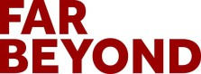



Energy Workforce Lunch & Learn

Abdelrahim Brown
Director, Energy Innovation (AERTC/GrIDD)

1

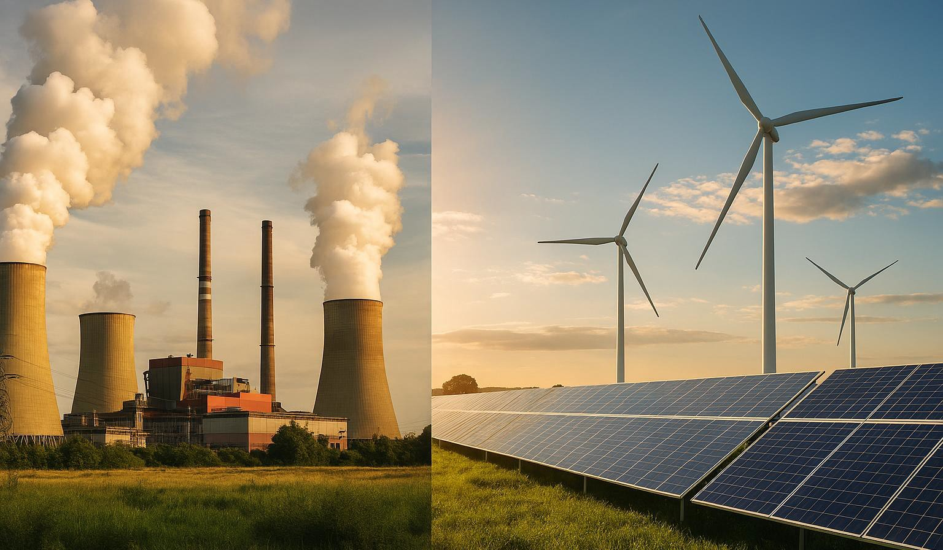
The Moment We’re In

What’s Driving Change

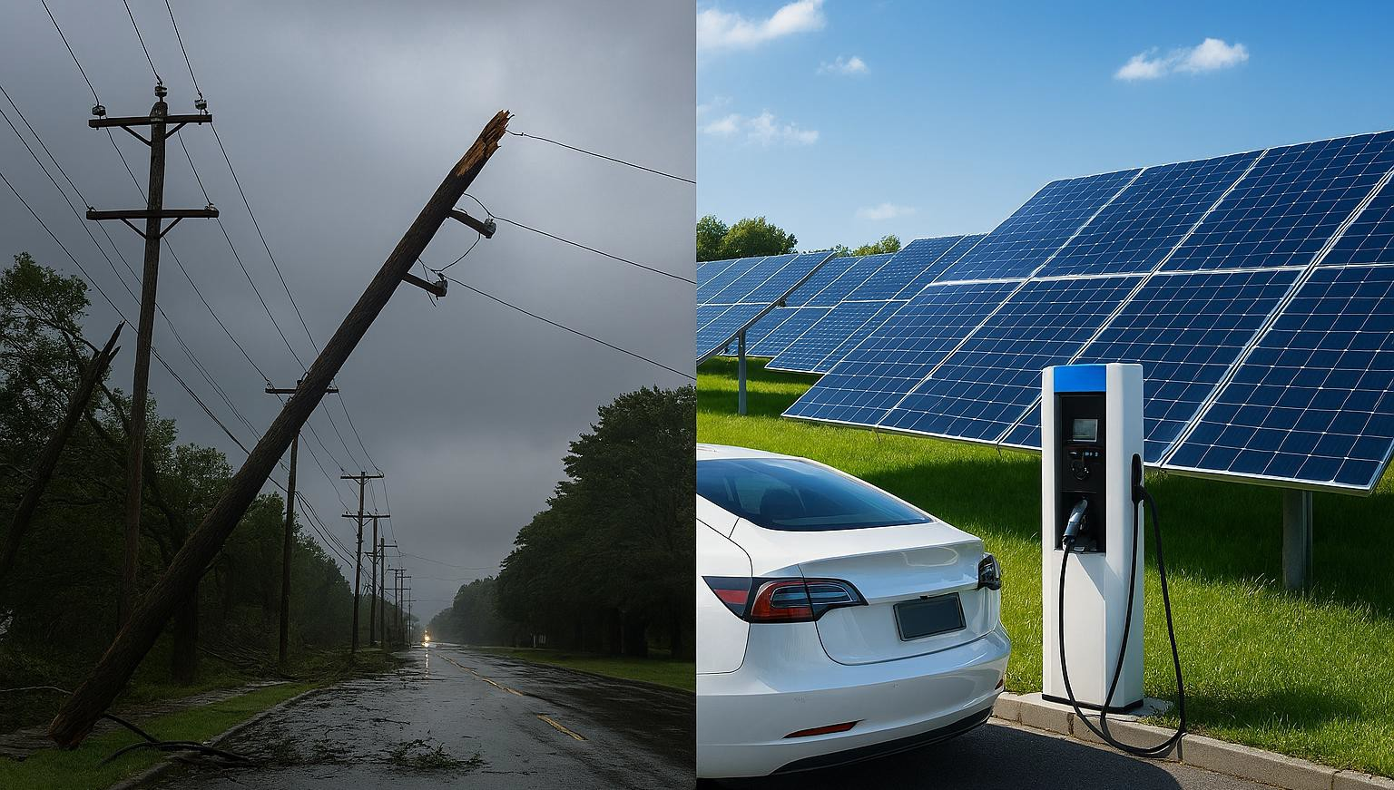
- More renewables
- More electrification
- More data
- More risk
- More innovation

Engineering Across Disciplines

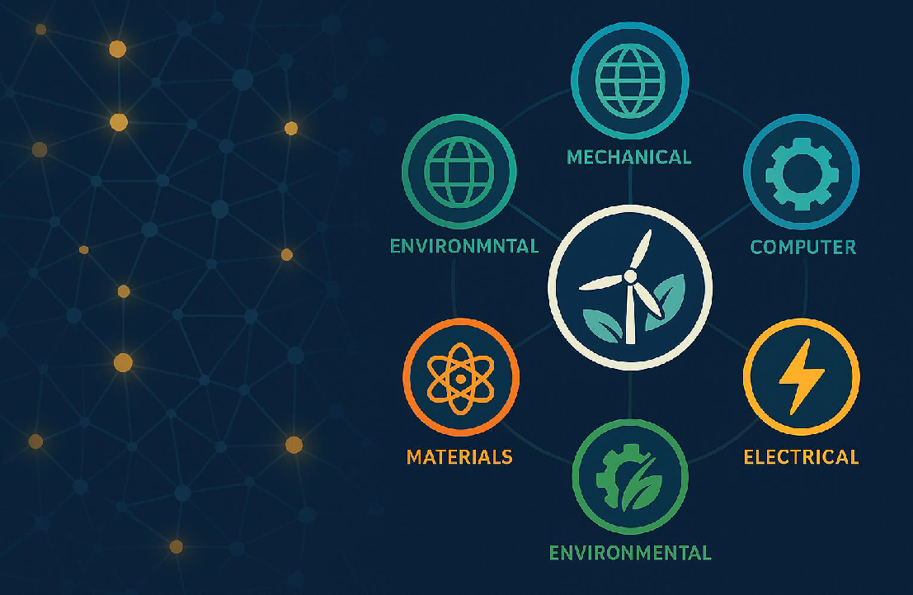
Energy needs every kind of engineer.

How Skills Connect

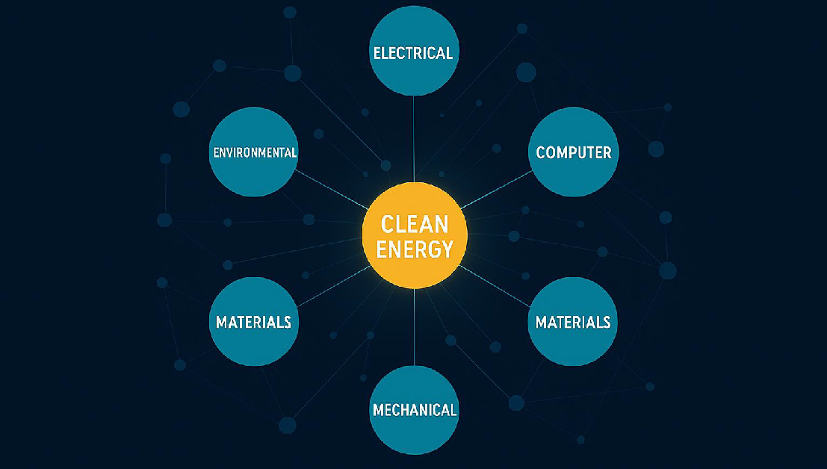
Your discipline shapes real solutions.

Digital Twin Studio: Our Shared Digital Testbed

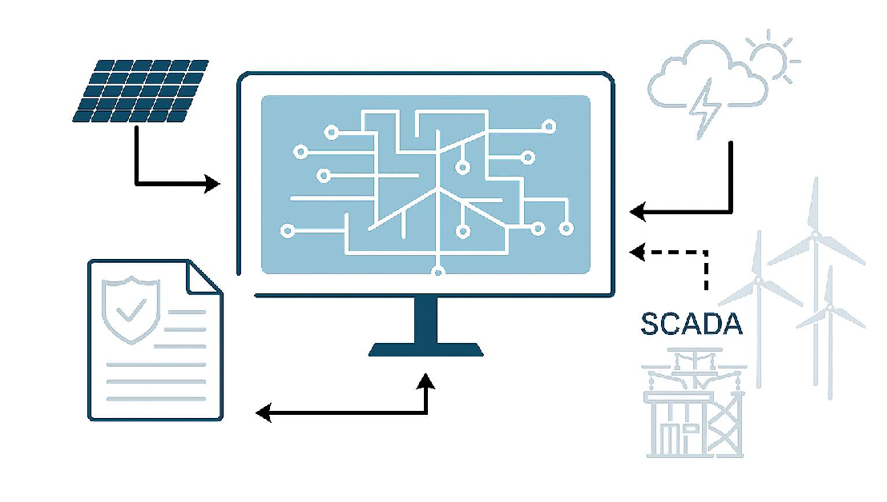
  - Real-time simulation of a representative neighborhood distribution network
  - Secure data from sensors, AMI, and weather systems
  - Use cases: outage & cyber forecasting | vegetation risk | asset health
  - Open API and sandbox for partners

HyPower Phase 1: Our Physical Testbed

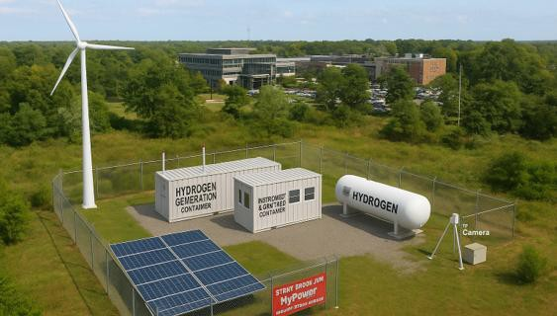
- DOE-supported hydrogen research platform at AERTC
- Modular containers with electrolyzer and
storage systems
- Powered by renewable energy sources (solar and wind)
- Integrated safety, controls, and monitoring systems
- Enables research and training on emerging
hydrogen technologies

How to Listen Today

  - The problems they solve
  - The skills they rely on
  - Where your major fits

Your Next Steps

Stay curious Ask questions Explore projects Build skills

