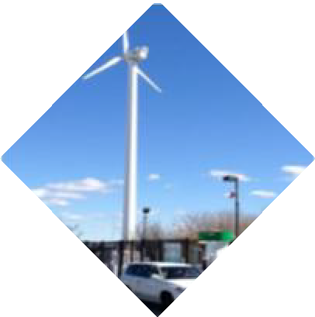



Engineering The Clean Energy Vision

Christopher A. Cavanagh, PE
Engineering Manager
Gas Asset Management & Engineering

November 19, 2025







An International Energy Company with a Local Presence
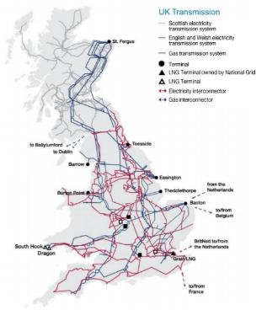

ACEEE policy rankings,
- UK’s largest electricity distribution network serves nearly 8 million customers in the East and West Midlands, South West and Wales,
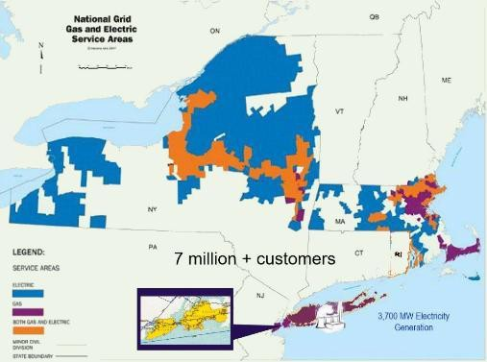
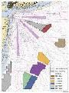

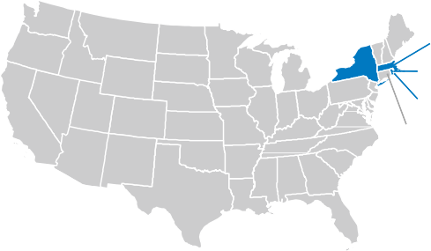
- National Grid Ventures
#
3
VT: #3
8
MA:#1
NY: #7
# 2
RI: #3
CT: #6
Our states lead
  - US Wind (Community Wind w/RWE)
  - Energy Storage

Goals for NY & similar for MA need more time!
 New York State Climate Leadership and Community
Protection Act – Signed by Governor July 18, 2019
 Statewide greenhouse gas (CO₂e) emission limits
 60% of 1990 emissions by 2030; 15% of 1990 emissions by 2050
 Statewide electrical demand system will be zero emissions by 2040
 Ground source heat pump qualifies as a renewable energy
system
 Rules and regulations to ensure compliance
 Regulatory measures for “beneficial electrification” of vehicles and
buildings
 Cost-benefit calculations, including social cost of carbon
 NY - Climate Action Council - Final Scoping Plan - December 2022
 Scenario 2: Strategic Use of Low-Carbon Fuels includes significant investment in renewable diesel, renewable jet kerosene, and renewable natural gas
 The Scoping Plan recommends the use of green hydrogen

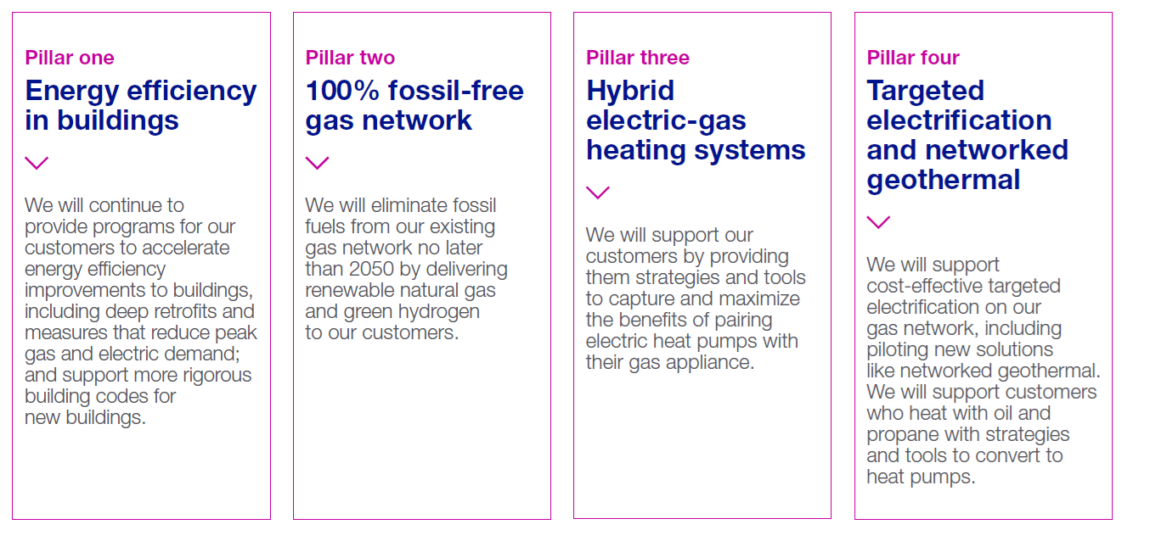

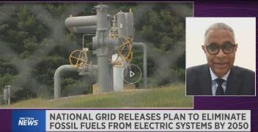
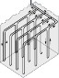

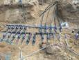
A better way to net zero

National Grid Plumbing Foundation of City of NY 10-24-2024 4

5

The energy markets are changing Fast

Traditional Energy Market - supply driven Today’s Evolving Market - customer driven





Customers focus on economic and environmental value, using a wider


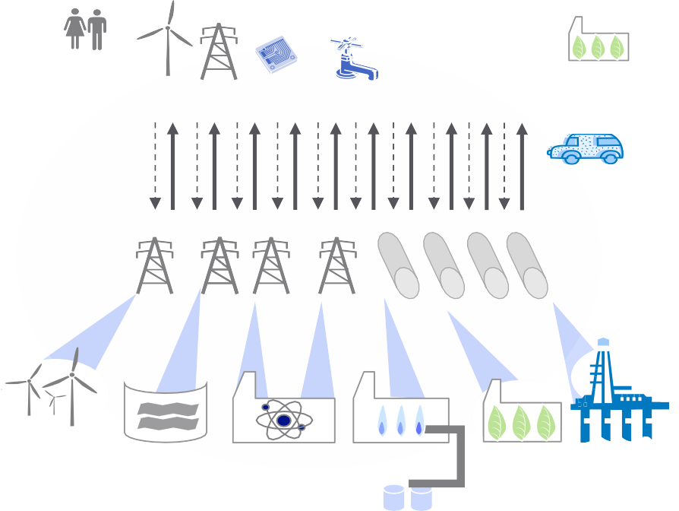

range of products and services

Large centralised generation

Domestic Industrial and

Micro wind

Micro CHP

Solar water heating

Heat Pumps

Efficient Boilers

Micro Biomass

Small range of conventional technologies

Nuclear power station

Hydro-electric power

Coal/gas fired power station

$$$

Gas production
commercial

Electricity flows to users, and surplus from distributed generation flows back to grid
Smart metering
+ Storage

Static infrastructure

Energy flows
to users
Energy volume drives energy company
revenue

Energy flows
to users

+ Storage

Intermittency management

Smart network technology rolled out

Technology choice proliferates

Natural Gas
Hydrogen
CO2
Biogas Heat

Industrial and commercial
Price and reliability are main determinants of customer
choice

Onshore and offshore wind

Hydro-electric power

Nuclear power station CCS plant (coal/gas)

Large scale CHP Gas production and biomass

$$$

CO2 emission reduction and wider energy services drives energy company revenue

CO₂ transport
and storage

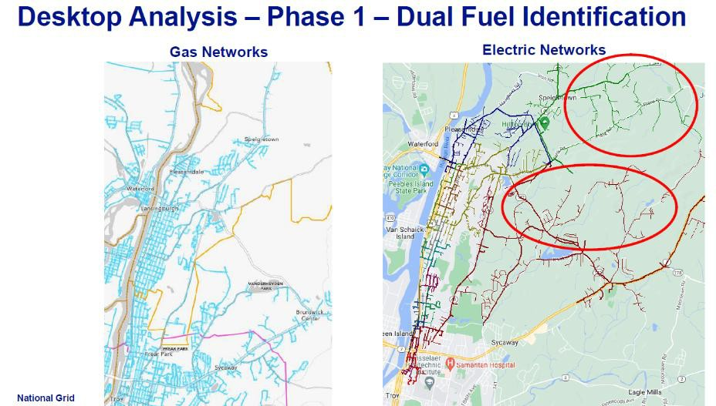
Example: Integrated Gas and Electric Planning
.

A New Approach – Regional Energy Modeling
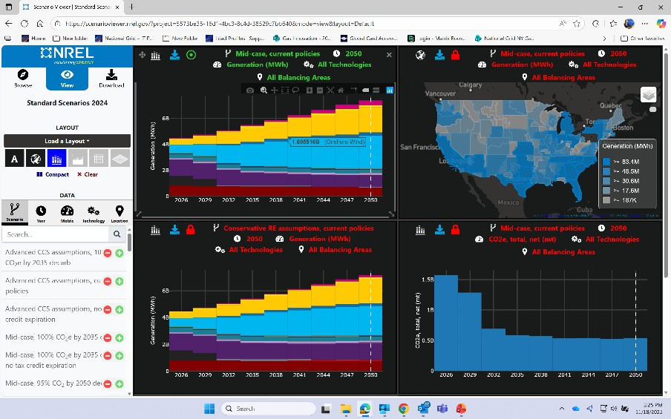

Stony Brook is Leading the Way in Low Carbon Fuels Renewable Natural Gas Hydrogen




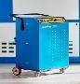
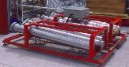
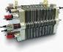


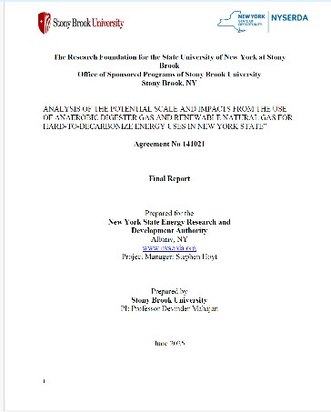


Solar Panel Wind Turbine
5 kW
H2
Fuel Cell Stack

Control Unit

Electrolyzer 4 Nm3/hr
Purification Unit Humidity Control
H₂ Storage unit 50 Nm


3
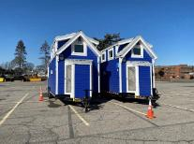

Workforce Skills & Opportunities

 Workforce Skills
 Engineering excellence is the starting point!
 Interactive infrastructure on both sides of the meter
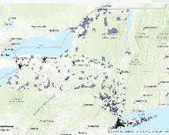
 Communications
 Diversity Equity and Inclusion
 Environmental Justice Communities ➔
 Entrepreneurship
 Business Development and Market Analysis
 Government Policy Analysis (Local ➔Global)

 New Opportunities
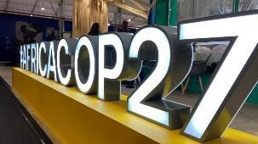
 Internships
 Professional Societies (e.g. IEEE)
 R&D
 Incubator Programs
 Global Programs


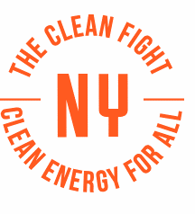
The Role of Academia
 Basic and Longer-Term Research
 Academic Relationships

 Access to Incubator and Start-Up Eco-system
 Access to Funding Sources 

 Objective and Independent

 Ability to Focus
 The Institute for Gas Innovation and Technology
 An institute of the Advanced Energy Reach and Technology Center at Stony Brook University; A university in the largest public university system in he US.

 Founded in 2017 by AERTC and National Grid
 Focused only on infrastructure efficiency, environmental performance and renewable energy technologies.



 Success in developing programs in the US for Renewable Natural Gas and Hydrogen
10
 A member driven- Industry-academic collaboration

National Grid SBU-SPIR



I-GIT: Established 2018





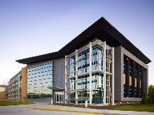
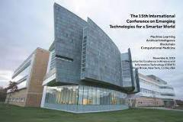


Mission: UseAcademic-Industry platformtoaccelerate deployment of advancedenergy technologiesand infrastructurefor gastoprovidecommunity residentsand businesseswithvalue-addedservicesaccomplishedthrough innovativeenergy research, analysis, education.



Built onfive-pillars
11
National Grid

With your help we can lead the way in creating the climate for change


Christopher.Cavanagh@nationalgrid.com
Going Forward

National Grid 12
12
nationalgrid

