

SBU SPIR Energy Lunch and Learn
Kenny Hass – WTG Operations Engineer

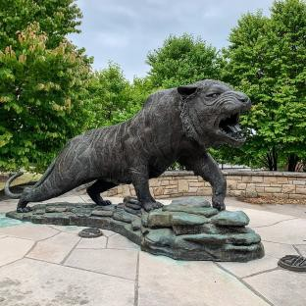
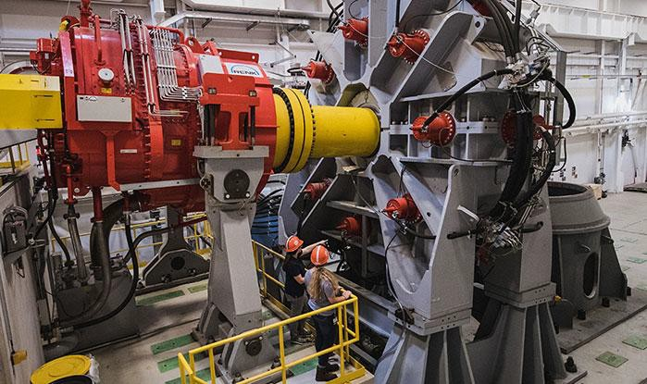
Background

- Born and raised in Stony Brook, NY

- Graduated RIT in 2020 with B.S/M.S. in Mechanical Engineering

- Started wind career at Clemson Wind Turbine Drivetrain test facility (Charleston, SC)

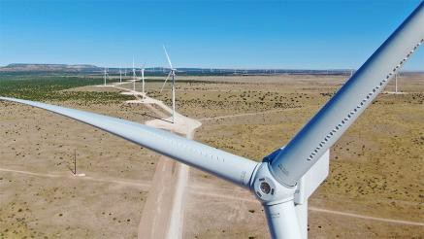
- Invenergy Wind Operations engineer 2021-2023 (Chicago, IL)

- Orsted WTG Operations Engineer Oct 2023 (East Setauket, NY)
  - First line of technical/engineering support to onsite technicians
  - Proactively identify issues before leading to downtime
  - Reactively perform root cause analysis for failures/faults
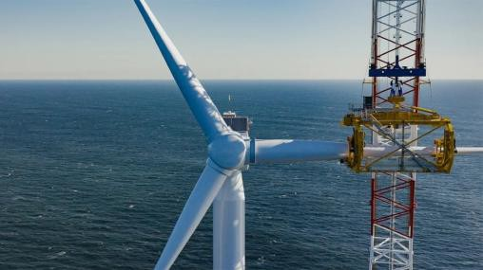
  - Performance and asset health monitoring

- Fun fact: Love to snowboard ☺

File:Rochester Institute of Technology Bengal Tiger statue.jpg – Wikipedia Wind Turbine Test Beds (clemson.edu)
South Fork Wind just became the US's first complete utility-scale offshore wind farm (electrek.co) https://twitter.com/GErenewables/status/1479437930754150411

Offshore Wind Components
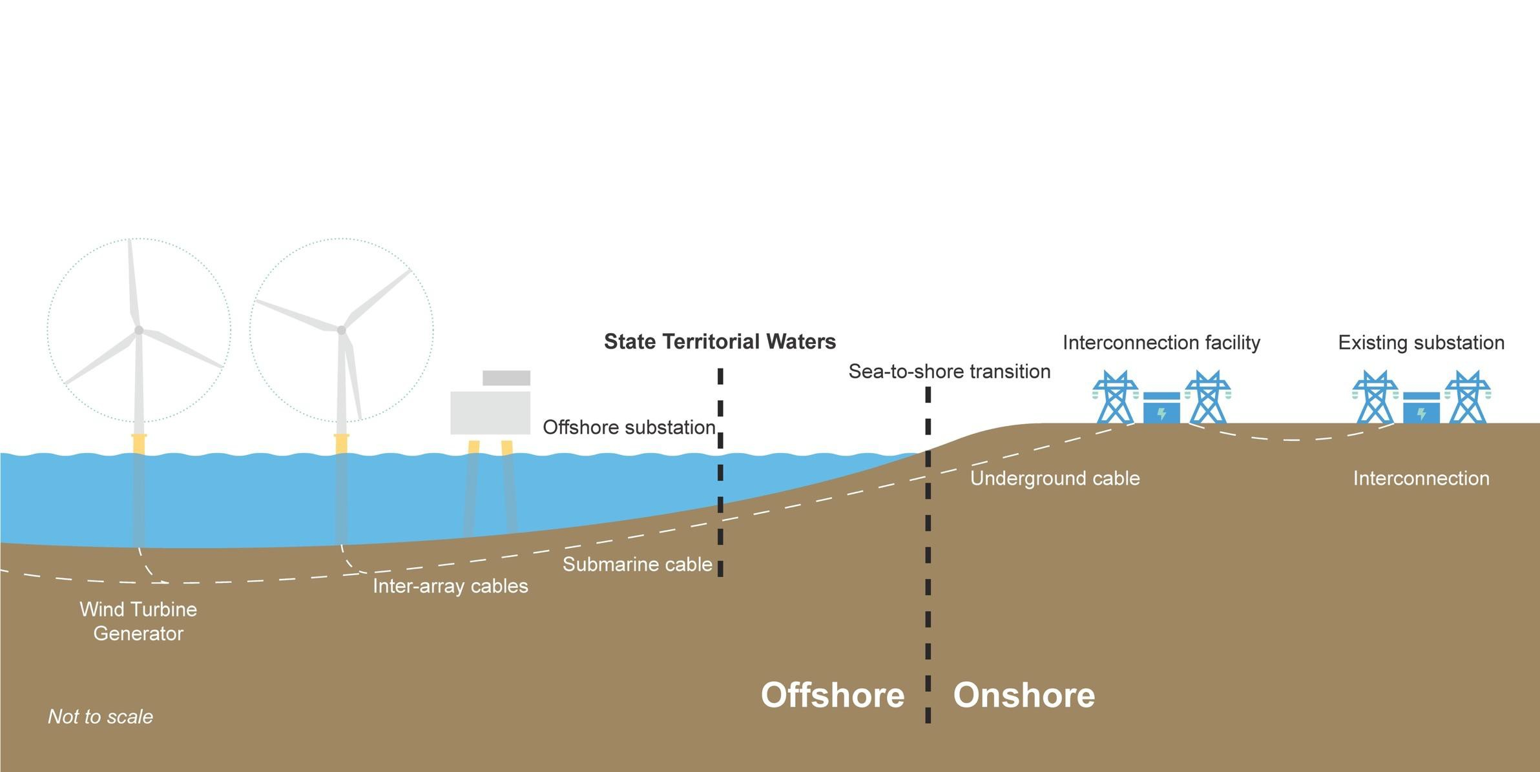
3

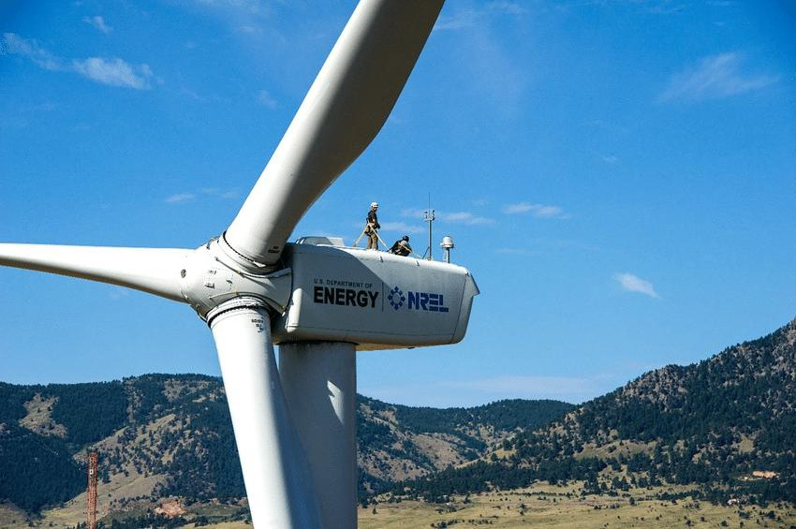
GE 1.5/77sle turbine at the National Wind Technology Center. Photo... | Download Scientific Diagram (researchgate.net)

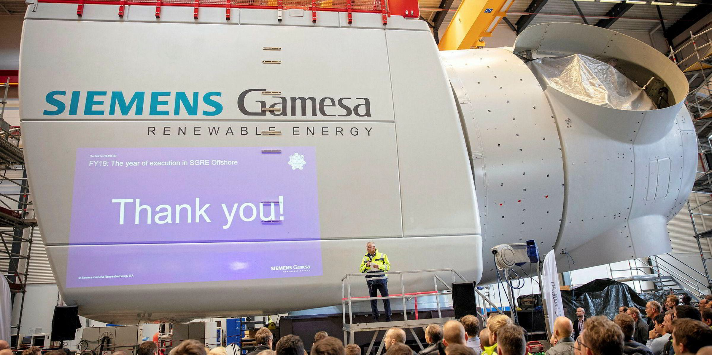

Siemens Gamesa’s first 10MW offshore wind titan unveiled | Recharge (rechargenews.com)

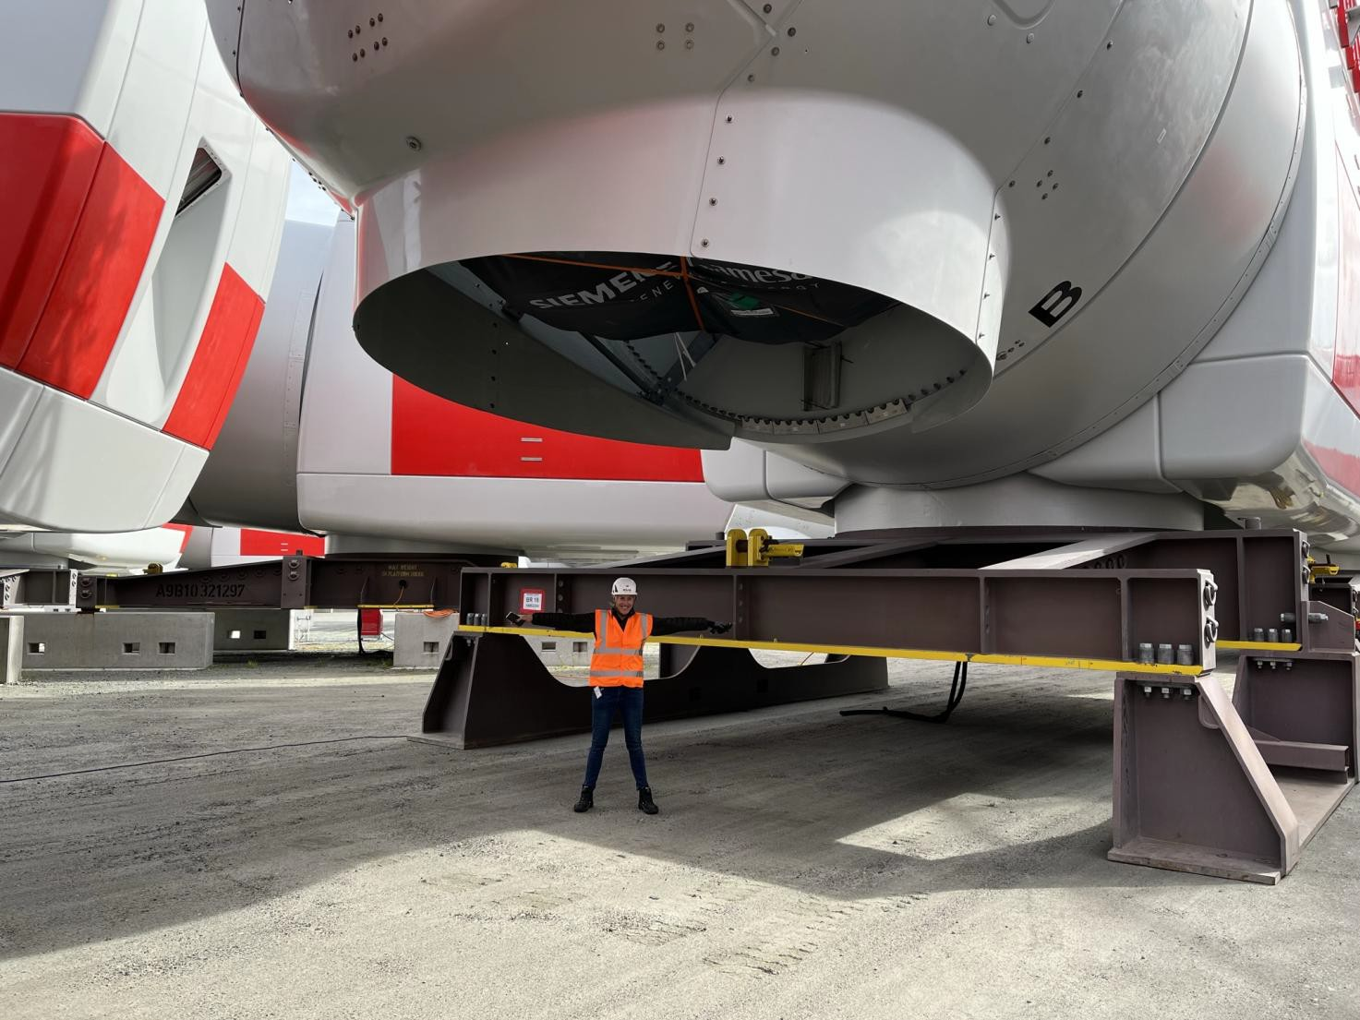

Nacelle/Hub Entrance

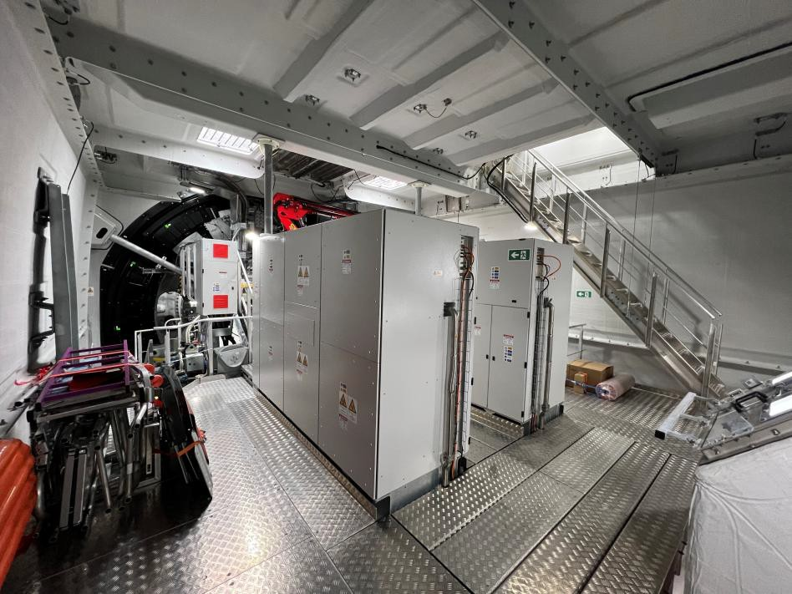
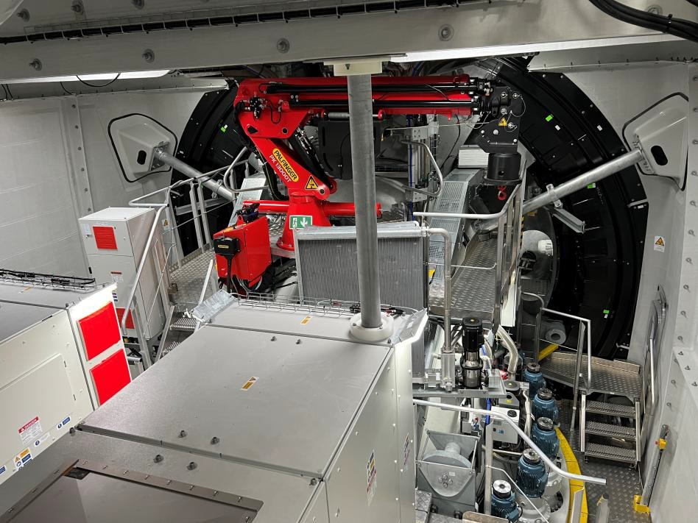

Crane and Turbine Control Cabinets

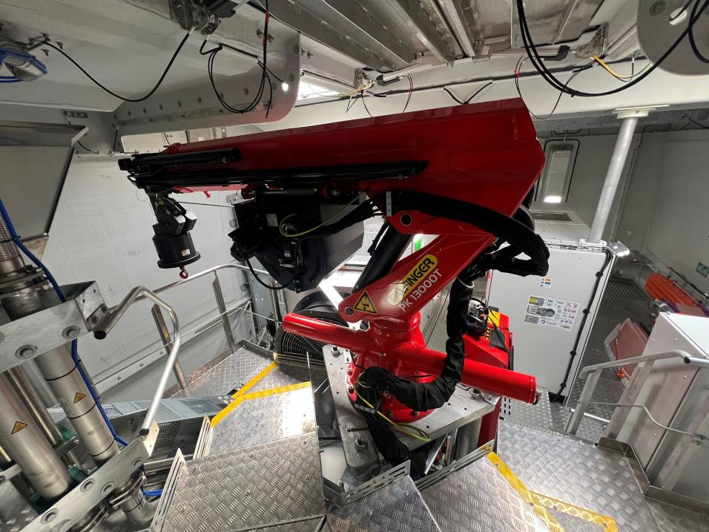
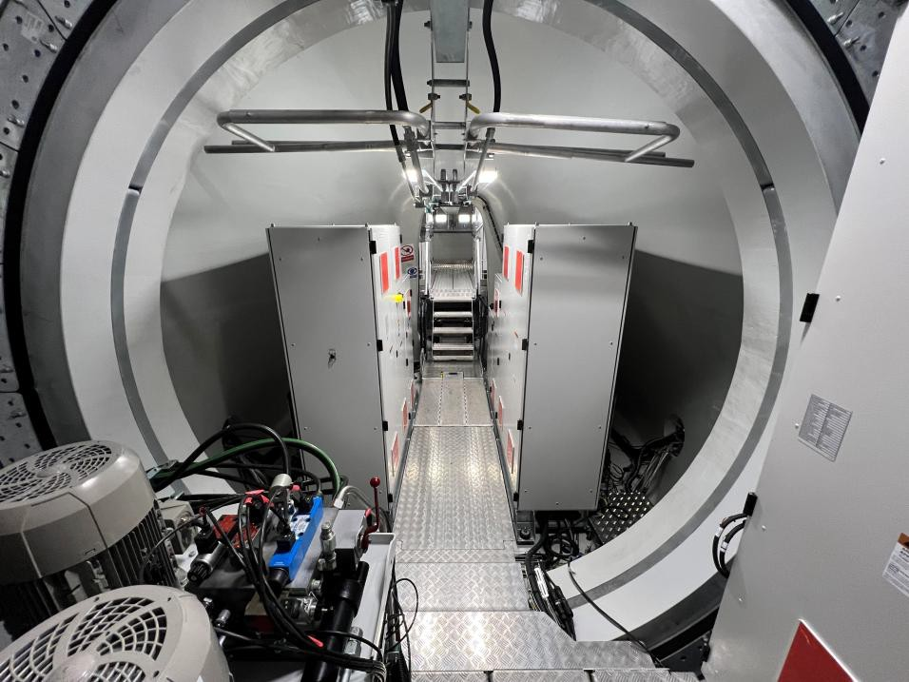

Pitch System inside Hub
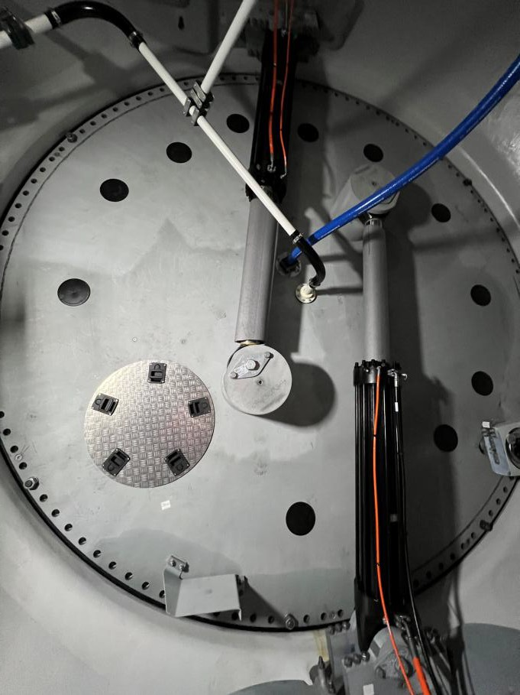
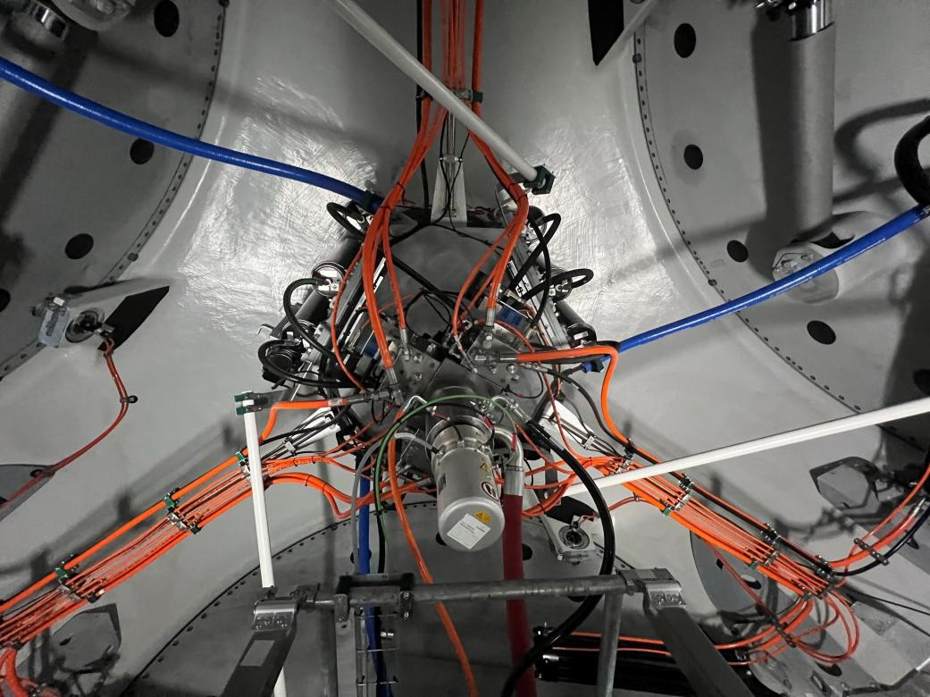

Yaw System/Converters
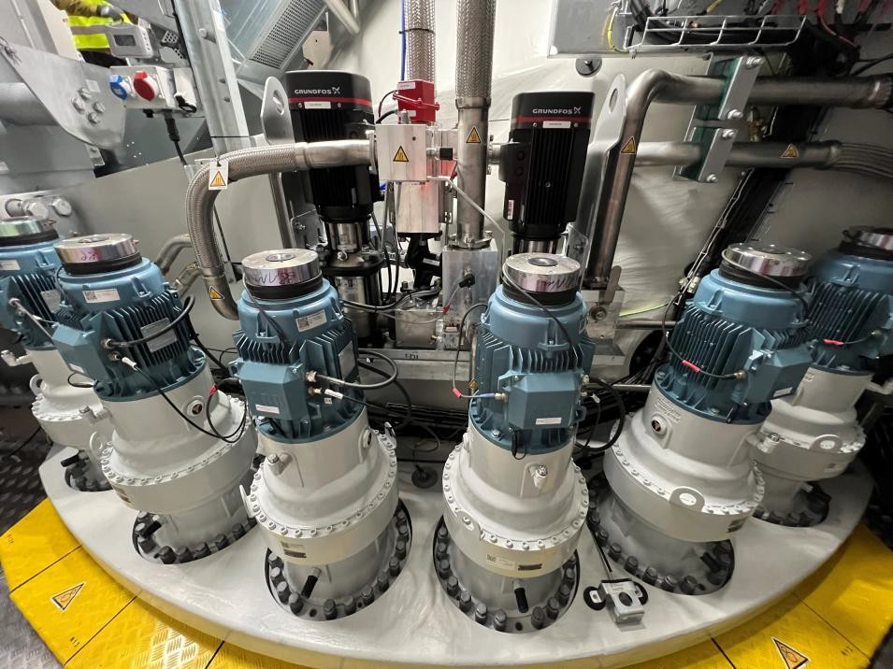
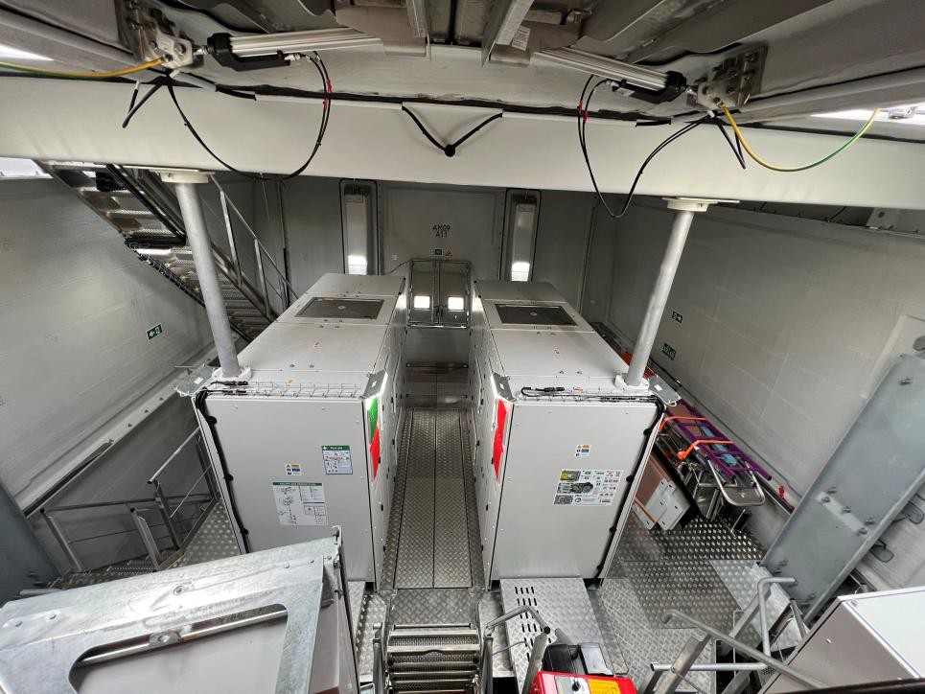

Offshore Wind on Long Island

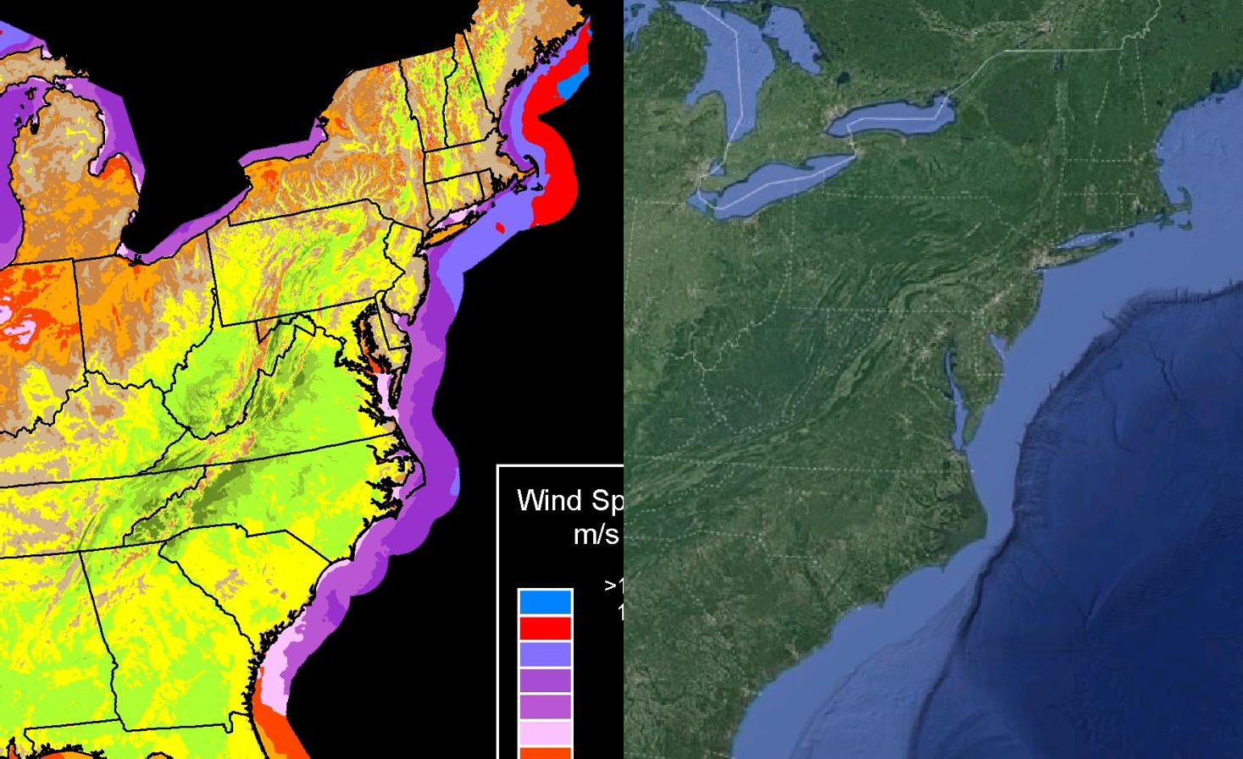
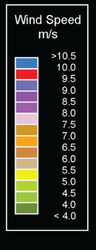
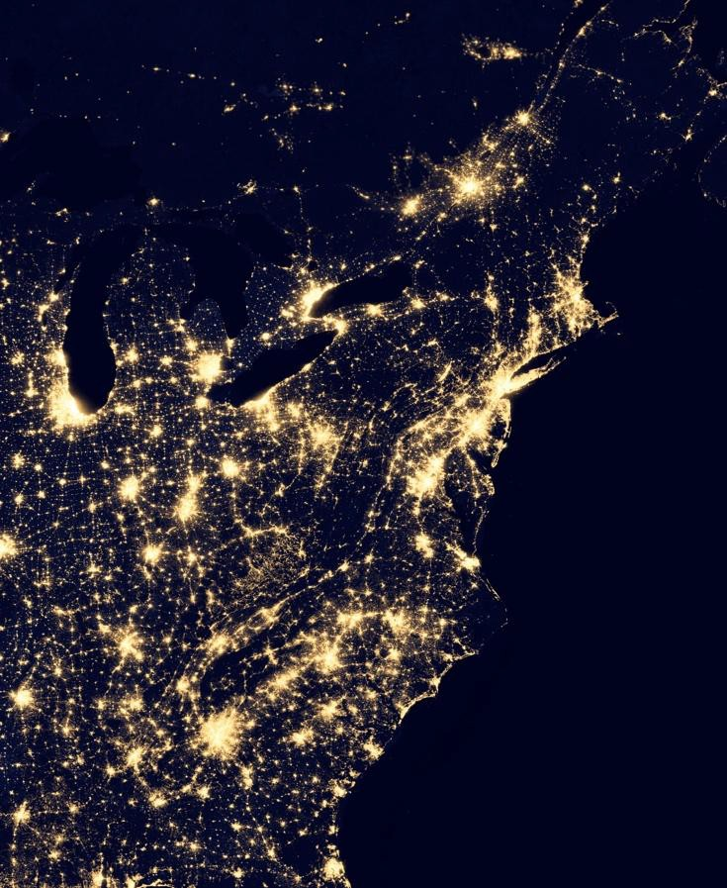
Huge coastal electricity demand
World class resource offshore
Large buildable continental shelf

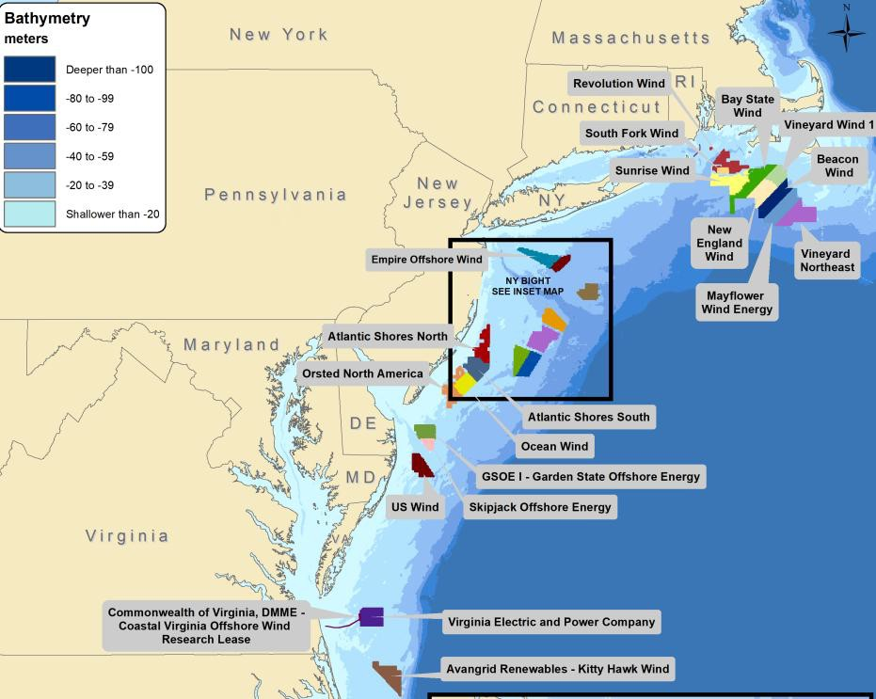
East Coast Offshore Wind Market Overview

- Biden Administration OSW target for the US was 30GW by 2030

- States set OSW targets and drive procurements.
- New York OSW goal is

9GW by 2035
12

Opportunities in Offshore Wind

Turbine/Foundation/Substation Design
    - Material Science, Strength of Materials, Dynamics, Controls, Composites, Vibrations, Fluid Mechanics, Heat Transfer, Electrical Eng

Wind Farm Development
    - Data analytics/numerical methods, Meteorology/Oceanic Studies, Statistics, Civil Engineering (Land Surveying, Foundations)

Wind Farm Construction
    - Marine Science, Environmental Studies, Rigging/Lifting/Statics/Strengths

Wind Farm Operations
    - Controls, Data Analytics, Strength of Materials, Vibrations, Meteorology, Marine Science, Coastal/Environmental Studies (and all
same areas as design for SMEs)

Narrow vs Broad opportunities available at all levels
    - i.e. Subject matter expert (SME) and main point of contact for one area, or more generalist weaving knowledge of multiple disciplines together

  - Opportunities for improvements and rapid change at all parts of wind turbine/farm life cycle

