myRESEARCH IBC TRAINING GUIDE

November 2019

Table of Contents
What is myRESEARCH 3
Getting a myRESEARCH Account 3
Overview 3
Roles in myRESEARCH 4
Submission Process 4
Logging into myRESEARCH Portal 4
Accessing the myResearch Portal 5
My Inbox ➔ Safety Tab 5
Safety Main Screen Navigation 5
Main Workspace 6
Creating a New Application 10
Overview of the Application SmartForm 12
Manage Ancillary Reviews 12
Submitting the Study 13
Clarifications Requested 14
Respond to Clarification Requests 14
Continuing Review 15
Amendment Request 15
Safety Incident Report 16

Questions and Issues
For policy related questions and issues including how to fill out the application, please contact the Stony Brook University Institutional Biosafety Committee (631) 632-9036; or Email ORC_OVPR@stonybrook.edu

What is myRESEARCH?
MYRESEARCH is the new electronic system that will replace IRBNet. It will automate the development, review, and approval processes of your study while managing all major administrative aspects of the research and compliance lifecycle – from application submission, through amendments, continuing reviews and any type of compliance reporting (i.e., protocol deviations, etc).

Getting a myRESEARCH Account
Faculty and staff users will log into the system using their SBU NetID and password. If your login attempt is unsuccessful, please contact ORC_OVPR@stonybrook.edu.

Overview
This training pertains to the following:

Research Study | Details related to the specific information related to a study
Research Study Site | Details related to a specific  institution’s site (study team, consent  forms, etc.)
Modification | Details related to changes made to a study
Continuing Review | Details related to the review of an already approved study

myRESEARCH integrates the following aspects of research management into a single system:

- Conflict of Interest (COI) applications
- IRB applications
- IACUC applications
- Safety applications
- Grant applications
- Research Agreements

Roles in myResearch

Registered User | Individuals authorized to input information in MYRESEARCH (must  have an SBU NetID Single Sign On)
Principal Investigator | Individual in charge of the research. Only this person can submit the initial study, continuing review application, or amendments. This is also the only person that can submit a response.
Study Personnel | Individuals involved in developing the study application and listed on the application as a study team member. A co-investigator or a  laboratory assistant could be a study team member.

Submission Process

- Pre-submission state: Principal Investigator (PI) or study team members are working on an application
- Pre-Review: IBC staff reviews the application for completeness
- IBC Review: IBC members review the application and make a determination about the study
- Post Review: IBC staff sends the determination information back to the PI and study team members

Logging into myResearch Portal
Navigate to myResearch.stonybrook.edu Click the Login using the NetID button (under IBC)
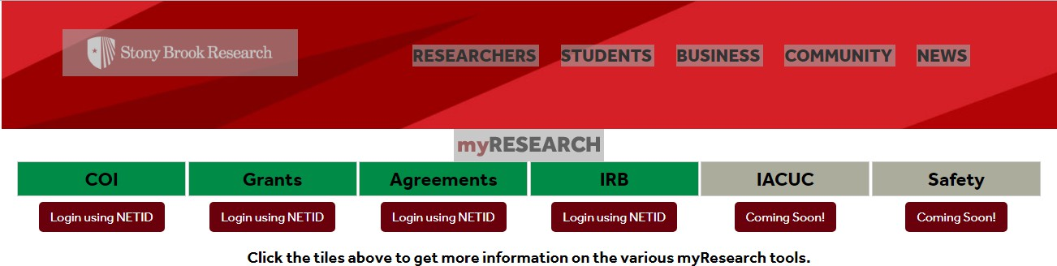

Accessing the myResearch Portal
All SBU-affiliated personnel can access the portal using their SBU NetID and password. If your login attempt is unsuccessful, please contact ORC_OVPR@stonybrook.edu.

My InboxSafety Tab
When you first log into the system, you will see your inbox (My Inbox). From this page, click Safety from the top menu bar. The tabs available to you on the menu bar are based on the user roles that you have for your account.

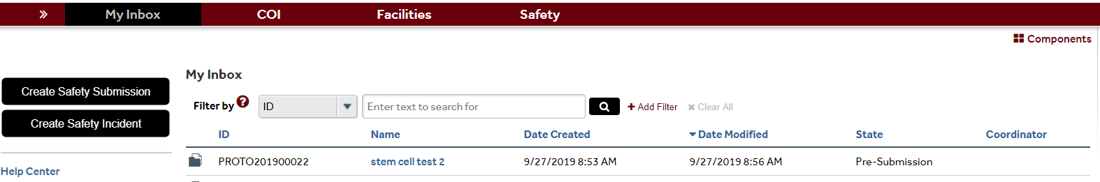

Safety Main Screen Navigation
On the Safety page, you can do a variety of functions including “Create Safety Submission”. You can also search for specific study applications (through the use of the filter bar) and sort the data based on column name (by clicking on the respective column heading). To view details of a particular study application, click on either the ID or the name.
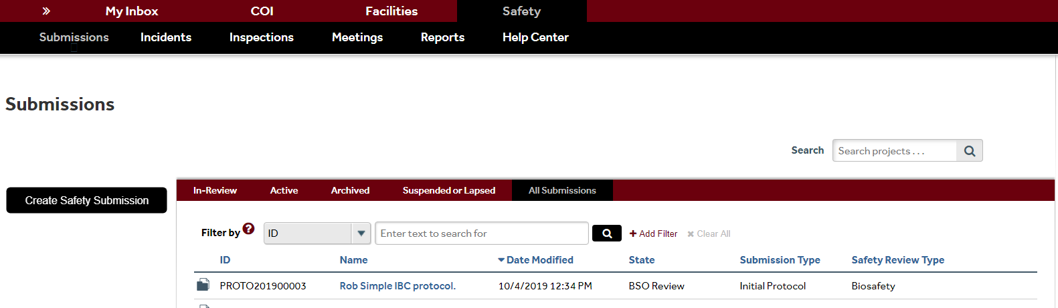

Main Workspace
The Main Workspace page can be subdivided into the left navigation area and the main content area on the right.
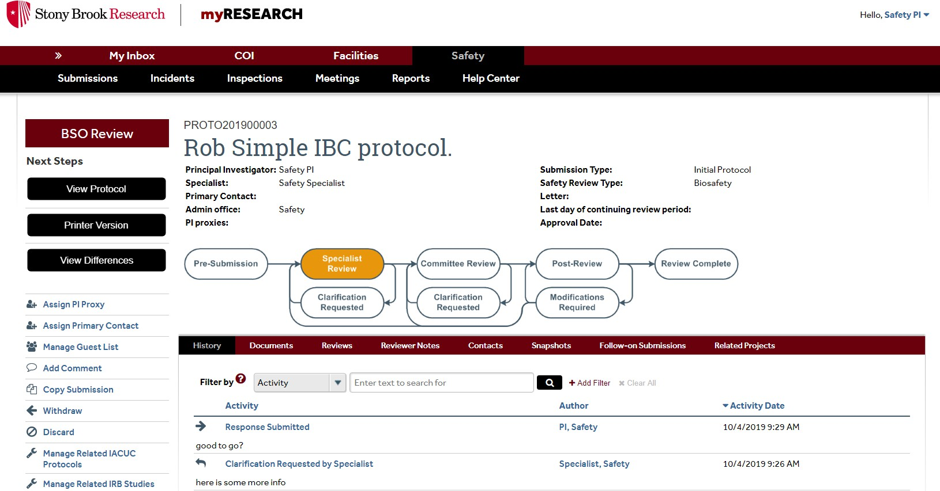
Left Navigation Main Content

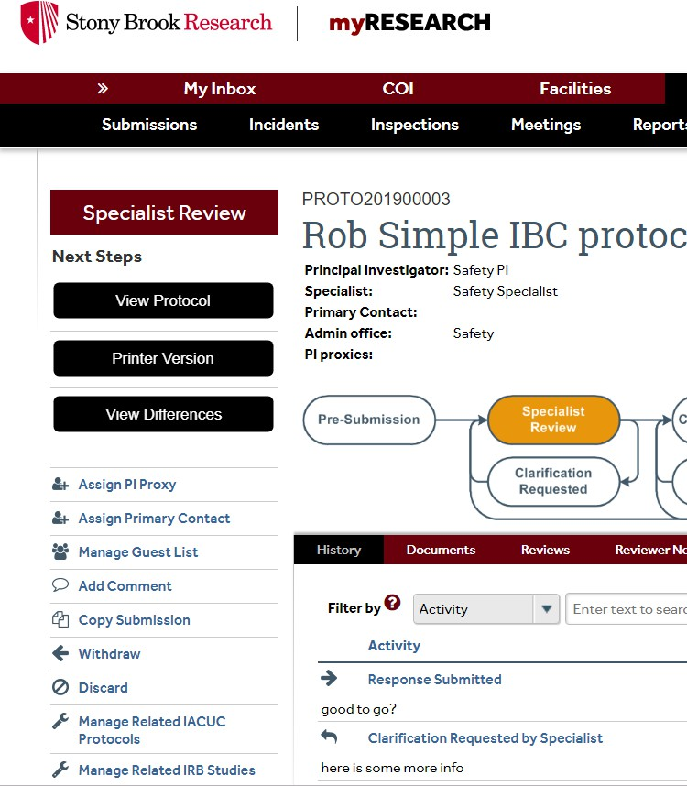
Within the main workspace, you can view the Current State of the application on the left navigation area and the main content area. The left navigation area contains all the buttons and activities that are available to you based on the state of the application. One of the buttons on the left navigation side of the Main Workspace is called “Copy Submission”. This allows you to make an exact copy of an existing application.

If the application is still in a state where you can edit the application, you can edit the application by clicking on the Edit Protocol button in the left navigation area. In addition, there will be a View Protocol button to enable you to view the application in a
read-only format. Printer Version will allow you to scroll through the entire application on one page.

The right side contains the Main Content. The application title appears towards the left of the Main Content area and the application ID is contained above the application title. A summary box is displayed below the application title. Depending on the application, there is different information that is displayed in the summary box.
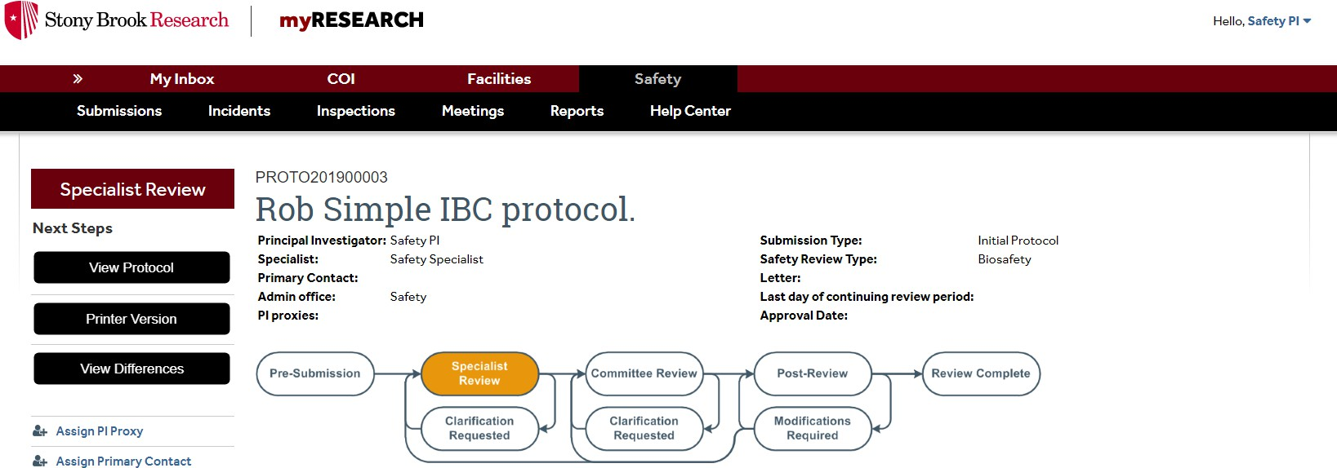

The History and Documents tabs always appear for all applications. The History tab contains a chronological log of all of the activities that have happened in the application. It includes the person responsible and the date/time the activity occurred. The Documents tab contains all documents that were uploaded into the application.
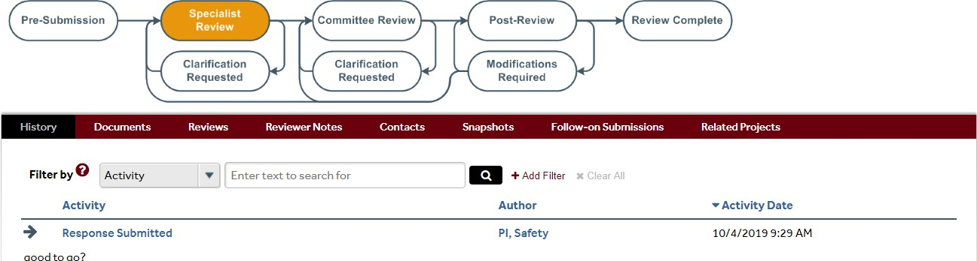


Creating a New Application
To create a new application, click on the Create Safety Submission button on the left navigation area. After you click to create the new application, you will automatically be redirected to the
first page of the “Formset” or area where the questions are located.

From there, you can navigate the page using the controls found at the top of the page.

While completing your application, one area will ask you to attach a file (if applicable).
Supporting Documents

A “Jump To” menu item will appear after you save the initial page of the application that will enable you to jump to specific sections of the application.

IMPORTANT NOTE: It is advised that you complete the application questions in order because the application shows questions/sections based on what was answered in earlier questions.

The “Hide/show Errors” menu item enables you to see if you have any unanswered questions
on the application.

When the “Hide/Show Errors” is clicked or when the click on “Submit Application” all of the questions that are unanswered will appear in an “Error/Warning Messages” section.
For each error message, there is a “Jump To” link that will take you directly to the question which applies to the error message. The application can only be submitted when all issues are fixed
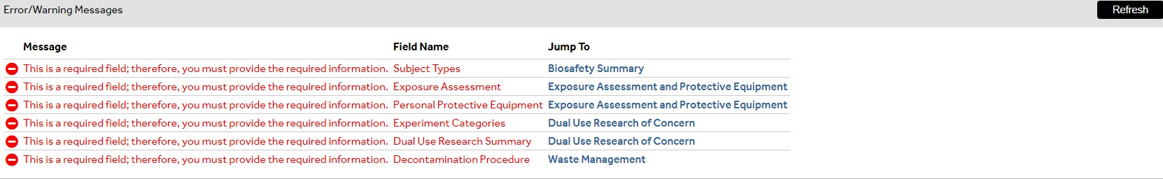

Overview of the Application SmartForm
- Each question on the SmartForm is numbered and those questions that have a red asterisk (*) must be answered.
- A question mark appears beside many of the SmartForm questions. If you click on the question mark, information will appear that will assist you in answering the question.
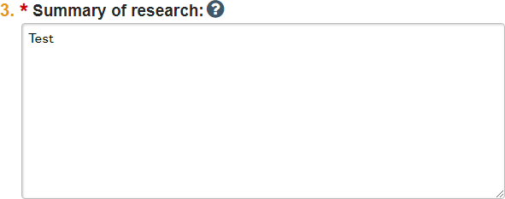


If you need to leave the application for any reason, you can save the document and return to the application at a later time.
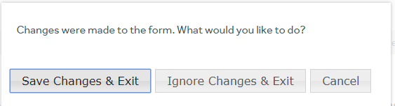

Manage Ancillary Reviews
Once you have completed the application you will reach a Final Page. Read the next steps on this Final Page carefully to ensure that all required ancillary reviews are requested.
  - For example, if your research involves a select agent, you will be required to click on “Manage Ancillary Reviews” in the left navigation area and add safety. You must receive approval from the pharmacy before you begin your study.
IMPORTANT NOTE: New studies require Department Chair approval prior to submission.

  - The PI’s Department Chair can be selected as an ancillary reviewer by carefully
following the instructions on the Final Page.

Submission of new studies prior to Department Chair approval is not permitted in myResearch. The PI must wait for an email notification of Department Chair approval before submitting the study.

Submitting the Study
Once an email notification of Department Chair approval is received, the study can be submitted for review. The PI must click on the Submit button in the study’s left navigation area.
An Investigator’s Assurance page will pop up. The PI must carefully read the assurance page and click the OK button on the bottom-right hand side of the page.
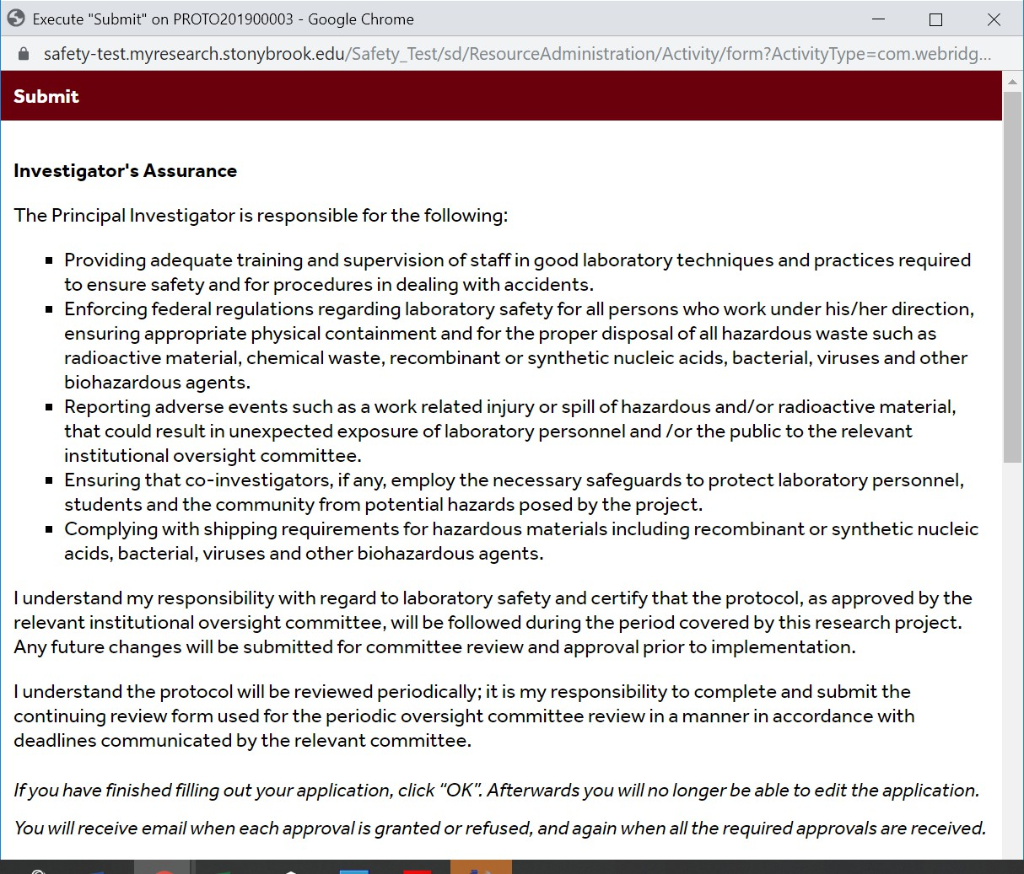

Clarifications Requested
Click the submission ID link in the email to open the document. Click the “History” tab and
review the “Clarification Requested” activity. NOTE: if the reviewer attached a document, a link to open it appears on the “History” tab.

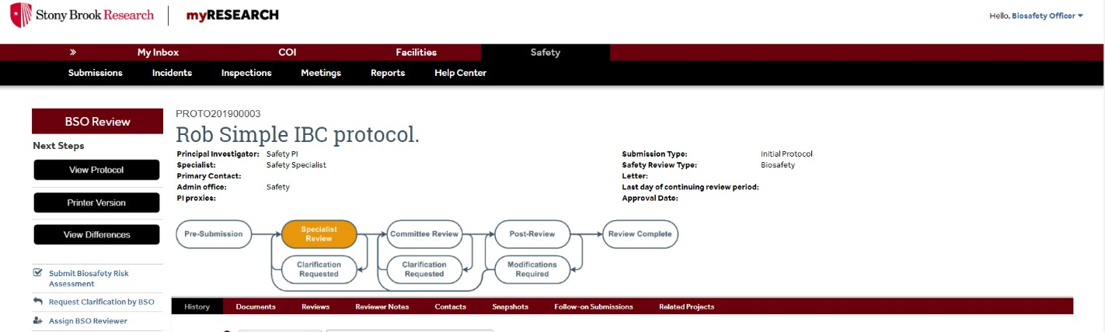

Respond to Clarification Requests
On the submission workspace, click “Submit Response”. In the Notes box, explain your response to the review. Click “OK”. The study has now moved back to the reviewer’s inbox to continue the review.
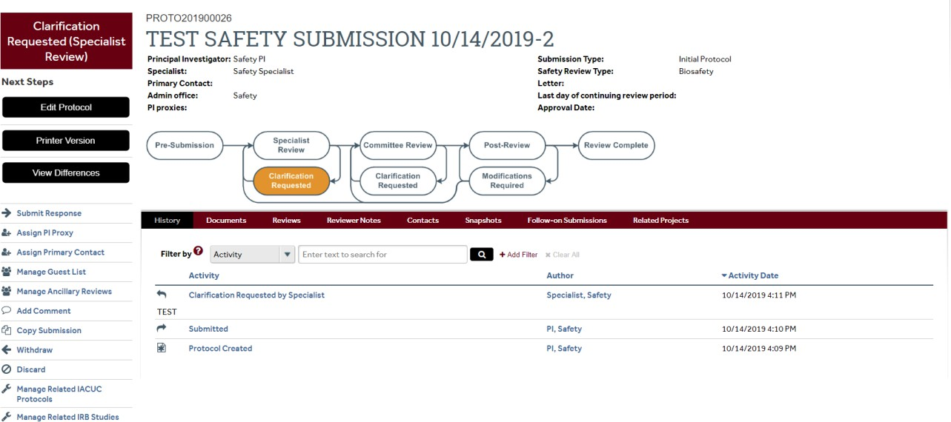

Continuing Review
You can submit a continuing review/annual review by clicking on the study in your inbox. Then click on Create Continuing Review in the left navigation area. This will take you to the questions asking about a continuing review of your research. Enter data in all required fields and submit the continuing review.

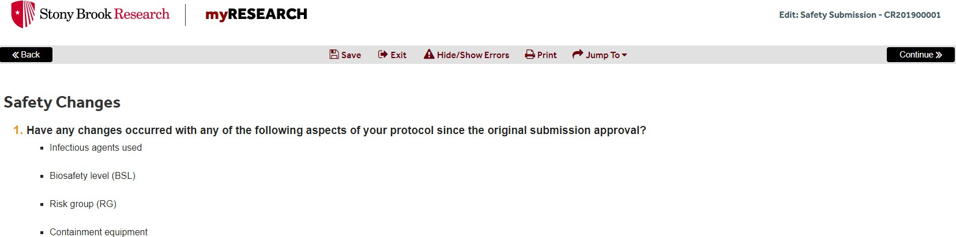

IMPORTANT NOTE: Continuing Reviews require Department Chair approval prior to submission.

Amendment Request
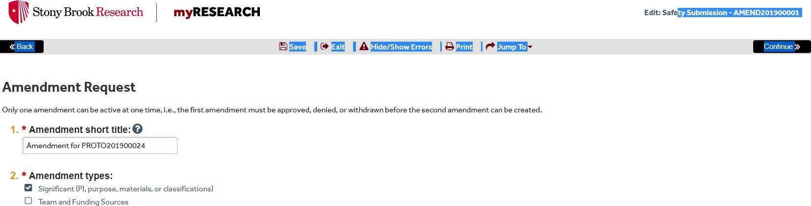
Click on Create Amendment in the left navigation area if you are submitting an amendment request. Enter data in all required fields. Submit the amendment

Safety Incident Report
Click on Create Safety Incident in the left navigation area if you are submitting an incident report.
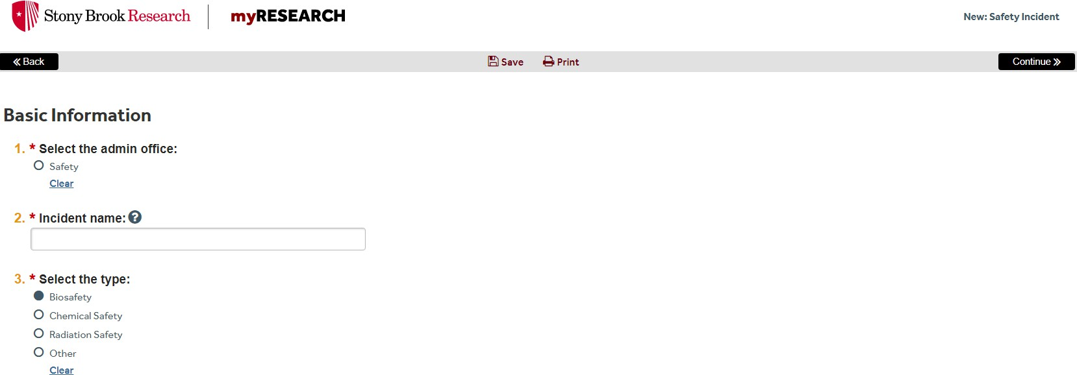
This area of the Safety Incident will ask you to describe the incident, the nature of the incident, any associated principal investigators, any related safety research protocols, where it was discovered and if there are any additional supporting documents.

