
To log onto CITI, go to: htps://www.ci�program.org/?pageID=668
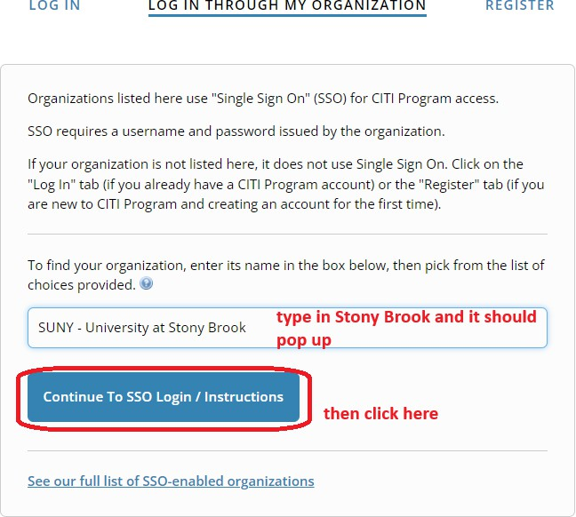

To add an appropriate course:

To add the Human Stem Cell Research Course:
The course should then be added to your Courses Ready to Begin list on CITI.

