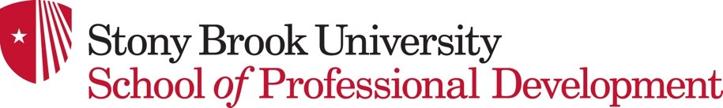

School of Professional Development Policy on the Responsible Conduct of Research and Scholarship

BACKGROUND
Stony Brook University policy requires members and specific Stony Brook University guests to complete educational training on the responsible conduct of research and scholarship (RCRS) to equip members with the tools necessary to conduct ethically sound and compliant research and scholarship.
While this campus policy originates in response to National Institute of Health (NIH) and National Science Foundation (NSF) training requirements, it is the opinion of the University that training on responsible conduct of research and scholarship should be more comprehensive. Jointly issued by the Office of the Provost, the Office of the Senior Vice President for Health Sciences, and the Vice President for Research and Innovation, the policy requires each academic unit to develop its own Complementary Policy for implementing the Stony Brook University policy to allow for the most appropriate requirements for the faculty, staff and students of that academic unit.
The educational program in RCRS involves two (2) components: online training provided by the web-based Collaborative Institutional Training Initiative (CITI) and in-person training (IPT).
The policy below outlines who in the School of Professional Development (SPD) is required to complete these training components, the required frequency of such training, and the general content of the training.

SPD TRAINING REQUIREMENTS
Online training (CITI)
All members (faculty, staff, students, and affiliates) of the School of Professional Development (SPD) who plan to participate as originators or contributors of research and/or scholarly activity under the auspices of or affiliated with the School of Professional Development will be required to complete the one-time only web-based Collaborative Institutional Training Initiative (CITI) training.
In-person training (IPT)

Members of the SPD community may be required to participate in additional in-person training dependent on the nature and scope of research. Faculty engaged in applied research activities are required to participate in additional RCRS training, at least once every three years, including SBU or SPD workshops or scheduled seminars. Graduate students who plan to engage in faculty-supervised thesis research projects are required to participate in one-hour of additional RCRS. All members participating in research supported by external funding must meet the minimum requirements set forth by funding entity.

DOCUMENTATION
Each SPD Graduate Program Director or Director of Programs is responsible for ensuring compliance with this policy, including maintaining accurate, verifiable records regarding individuals’ completion of CITI and IPT programming. Individuals who complete CITI training should retrieve their certificate of completion and email it to their program director. In addition, all CITI completions will be recorded and noted in a centralized SBU database.

RESOURCES
- Stony Brook University Policy on the Responsible Conduct of Research
- Collaborative Institutional Training Initiative (CITI Program)

