INSTRUCTIONS ON HOW TO SUBMIT DELIVERABLES/PROGRESS REPORTS THROUGH MYRESEARCH

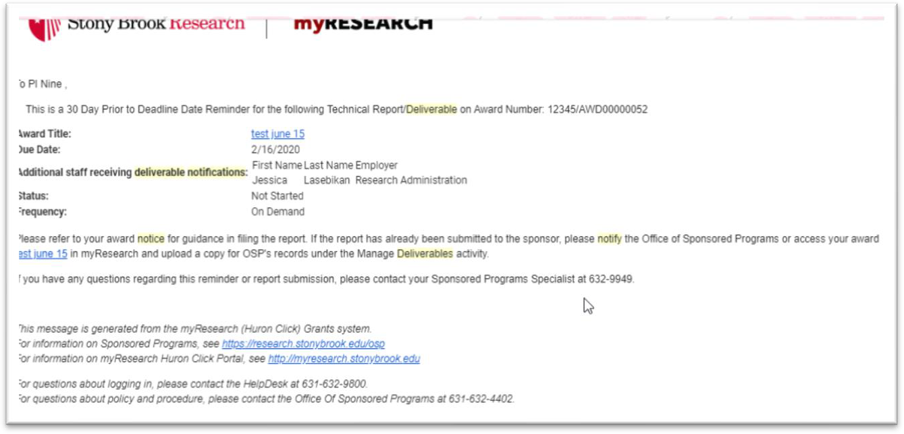
myResearch will generate an automatic notification 60/30 days prior to the due date of a report, on the due date, and 30/45 days after the due date (overdue notifications), until completion. The notification will reference both the Oracle award number as well as the myResearch award number. The PI, CoPIs and any additional staff included on the award will receive the deliverable notification.

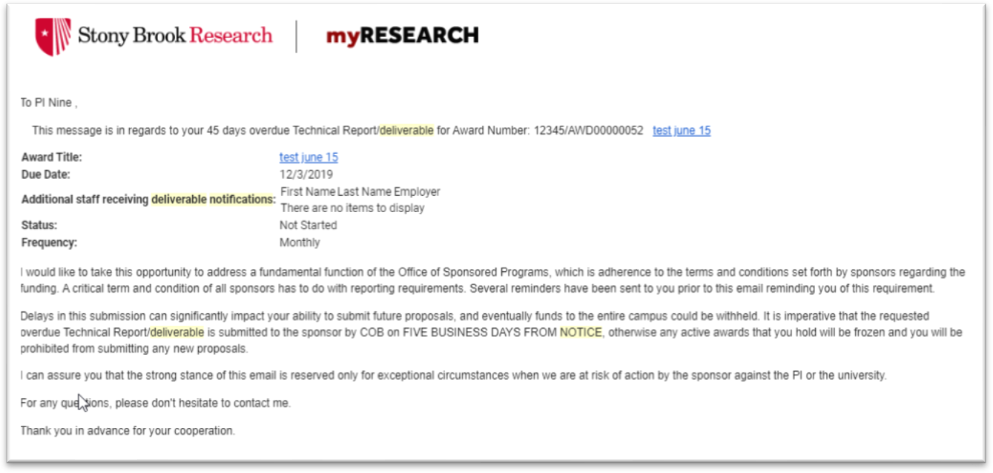
Sample 30 days prior to due date message

Sample 45 days OVERDUE message

Upon receipt of the notification, and whenever ready to submit the report, access your myResearch
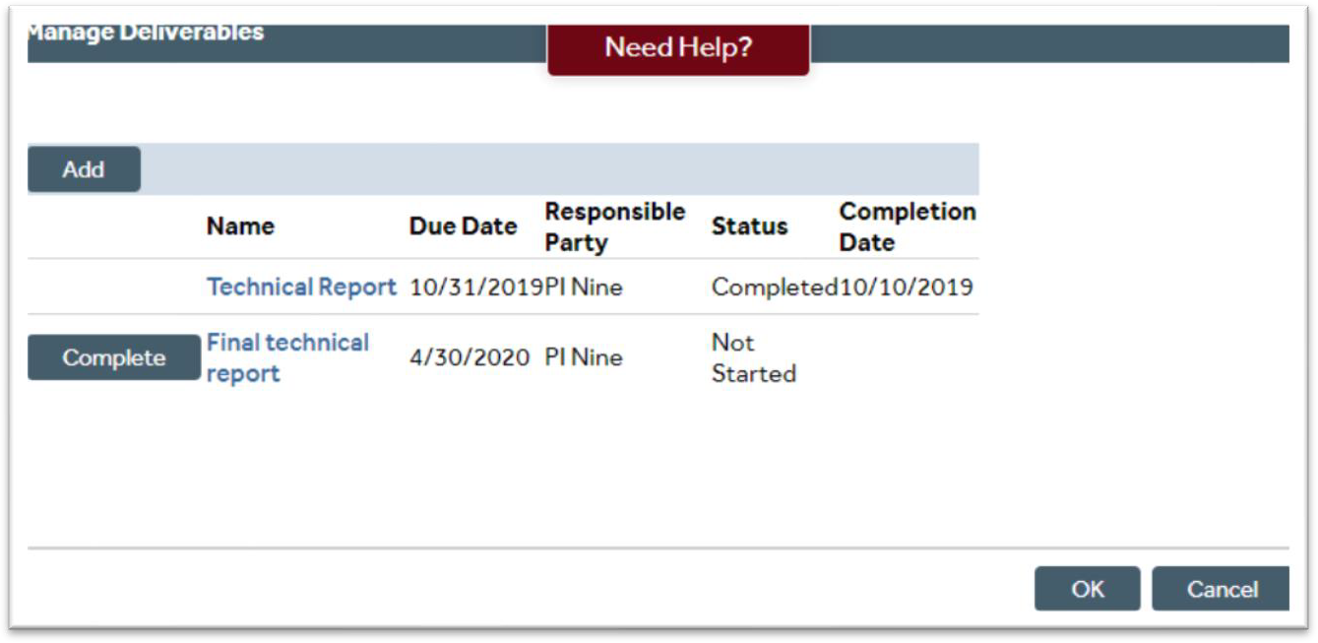
award record (AWD…..) and click on on the left side of your screen.
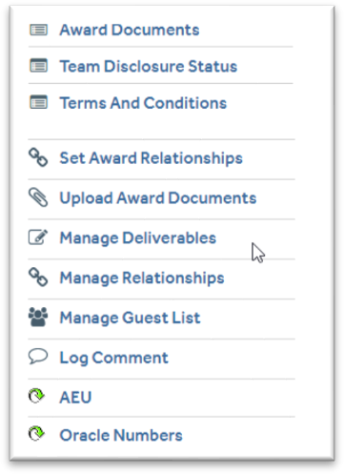
You will be redirected to this screen:



Select the due report by clicking . Fill in the mandatory fields, attach the report, and click OK. Note that NIH/NSF reports DO NOT have to be attached as they are submitted through sponsor portals that OSP staff have access to.

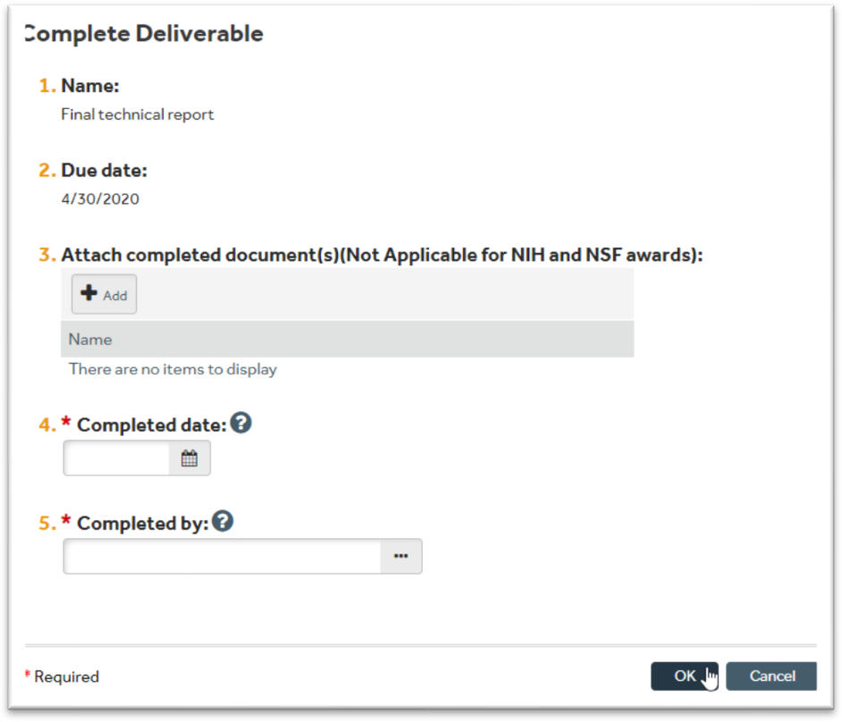

Once you complete all the fields and click OK, a new window will be generated which will show the Status and Completion Date. Click OK.
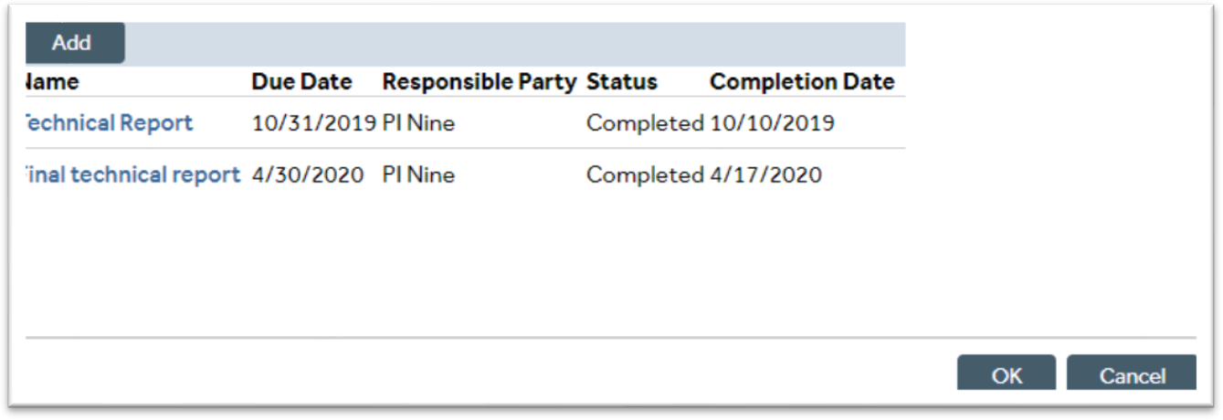

The Office of Sponsored Programs will receive a notification and a copy of your report for filing or submission to the sponsor, if requested to do so by the PI.

