Department of Languages and Cultural Studies
Fall 2025 ~ Monday/Wednesday, 11 am–12:20 pm

HUF 320: Transnational Issues in the Francophone World
Prof. FRANCK DALMAS

FRANCE – CHINA CROSSINGS


This course presents cultural contacts between France and China through the background histories of the French colonial empire in Indochina, ensuing settlements in Guangzhouwan and Shanghai, literary encounters of Chinese travelers/diplomats with 19th-century French authors and sinologists. We will read, in translation, significant texts or short novels by both French and Chinese francophone writers. The course will also illustrate the study material in films: Indochine (1992), screen adaptation of Balzac and the Little Chinese Seamstress (2002), animated short of the folktale Wang-Fô (1987). Away from decolonial views, the course will make a strong case for francophone partnerships in the global world on account of a cross-cultural “cohabitation.”

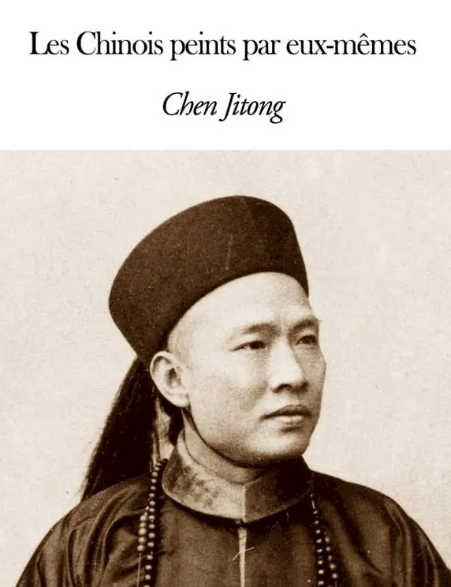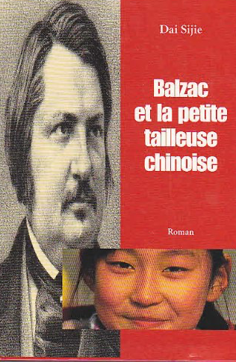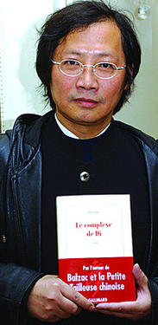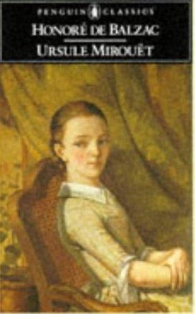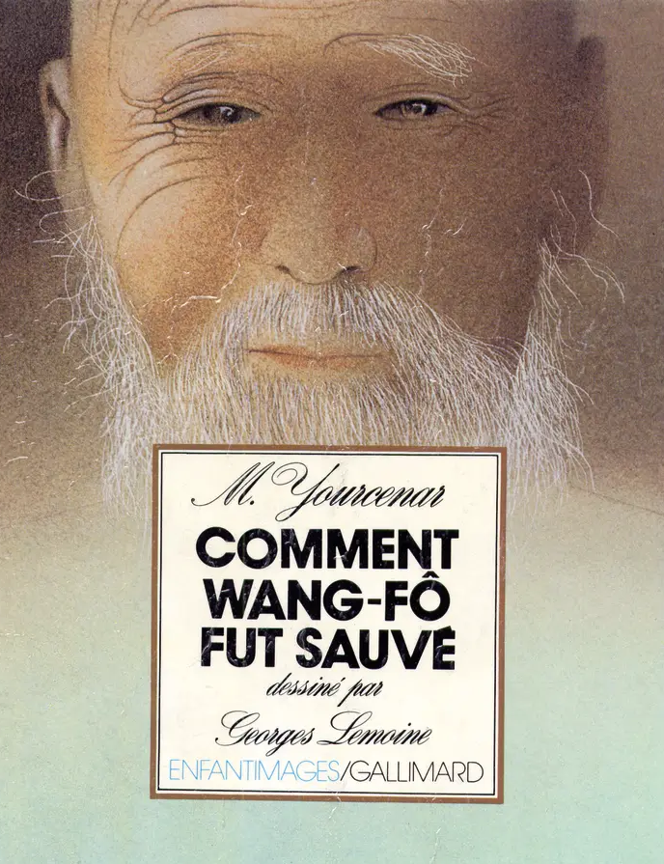
Left to center: first Chinese francophone writer Chen Jitong (1851-1907); Franco-Chinese author, filmmaker Dai Sijie (1954- ). Center to right: 1841 novel Ursule Mirouët by Balzac (1799-1850); fantastic tale Wang-Fô by Marguerite Yourcenar (1903-1987).

