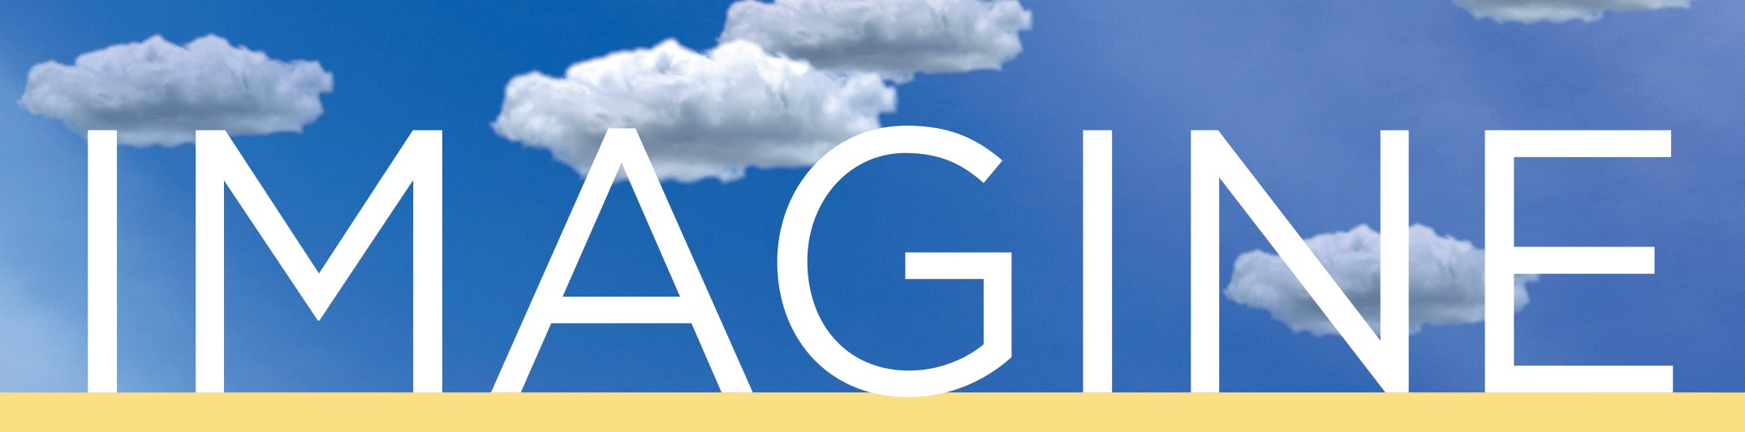

@wolfiewriters

FALL
WEDNESDAYS

Melville N3045 - 12:30-1:30PM

2025


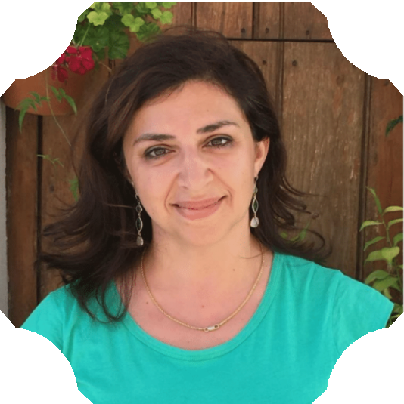
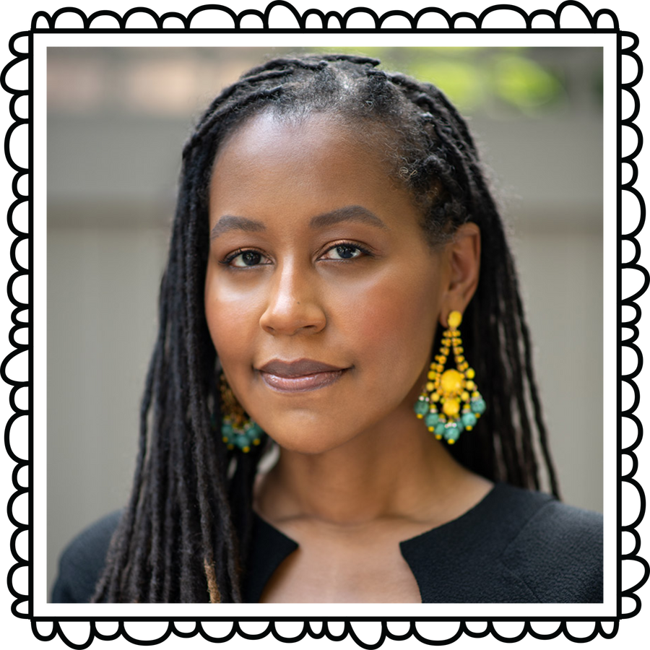
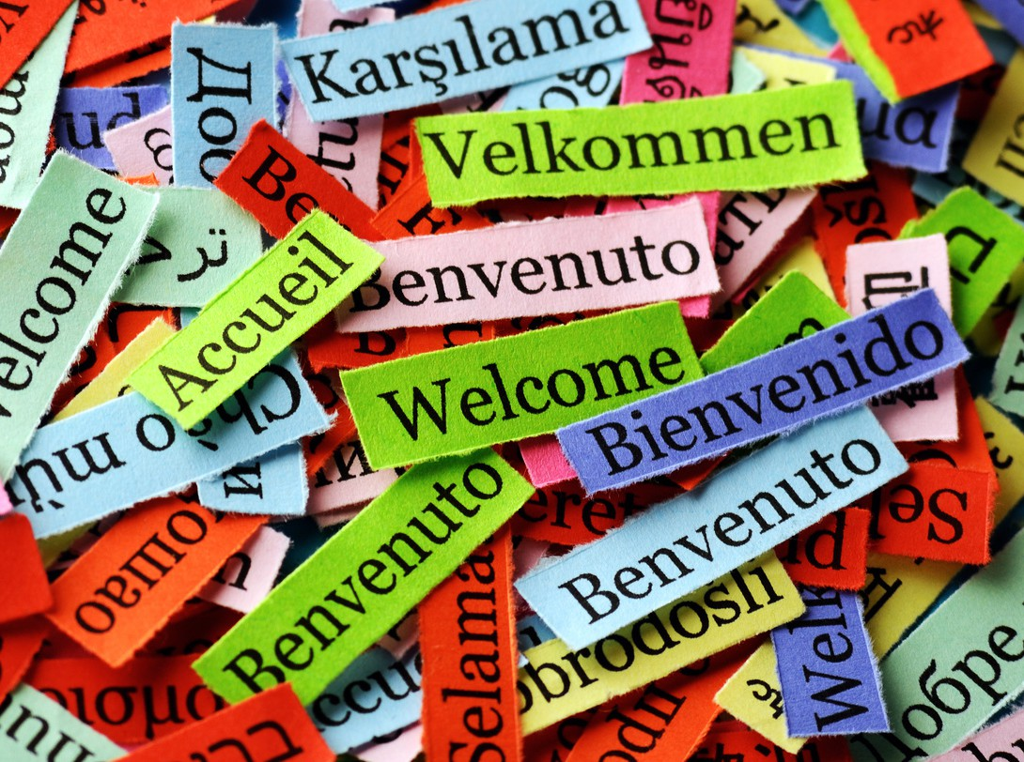
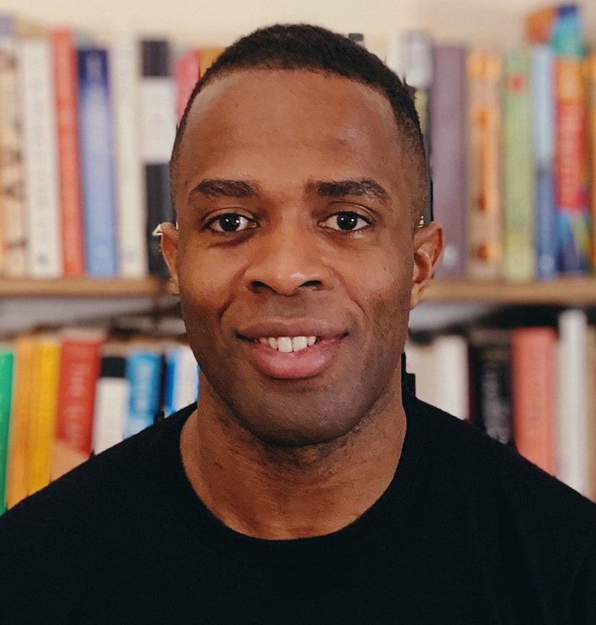


SEP. 10 ~ Welcome Back Event
New and returning students gather in Melville N3045 “Fishbowl” to kick off the new term with inspiring word games, new friends, and yummy pizza!

OCT. 15~ Faculty Reading + Q&A w Dawnie Walton Dawnie Walton is the author of The Final Revival of Opal & Nev, winner of the 2022 Mark Twain American Voice in Literature Award, the Aspen Words Literary Prize, the VCU Cabell First Novelist Award, and the Audie Award for Fiction.
NOV. 5 ~ Visiting Author Lena Khalaf Tuffaha

Interactive Reading
Lena Khalaf Tuffaha is an Arab American poet, essayist, and translator. She is the author of three books of poetry, including Something About Living (winner of the National
Book Award).
NOV 19~Faculty Reading+Q&A w Eskor Johnson
Eskor David Johnson, author of Pay As You Go- an NPR Best Book of 2023 and finalist for major fiction prizes-has published in McSweeney’s, Guernica, and The Believer. He holds degrees from Harvard and the Iowa Writers’ Workshop and is originally from Trinidad and Tobago.
DEC. 3 ~ Undergraduate Student Showcase
Undergraduate writers, it's your time to shine! Nominated writers will have the chance to share their work with their peers in a public reading. Family and friends are welcome. Refreshments served!
To request accommodations or more information, please email cwlundergrad@stonybrook.edu

