Energy: The Next Frontier

NYS Advanced Energy Research and Technology Center

Dr. Yacov Shamash
Vice President for Economic Development and Dean, College of Engineering and Applied Sciences, Stony Brook University

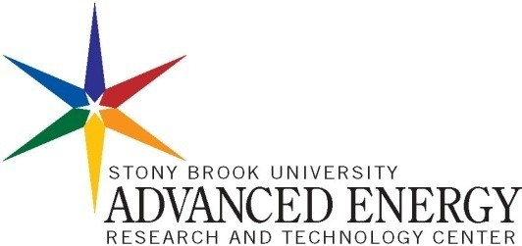
Gen5 Ceramic Consortium 2006 Garden City, Long Island, N.Y. September 7, 2006



The mission of this Center will be to forge partnerships between universities, industries, and national laboratories in order to develop reliable, economical, and plentiful sources of energy that will ensure sustained economic development of the region without impairing the natural environment.

Objectives

- Establish a broad based interdisciplinary research program which integrates fundamental science, nanotechnology, and engineering to design next generation advanced energy systems - renewable energy sources, molecularly engineered traditional fuels, cutting edge fuel cell technology.
- Build full scale demonstration and testing units which will evaluate new technologies; solar, biomass, hydrates, and cogeneration with traditional fuels.
- Design a working “green” power plant that incorporates wireless technology with fundamental research to evaluate the economic factors of zero emissions power generation and establish standards for safety and environmental impact.
of the power grid to optimize the distribution network, provide alternatives in case of local failures, and provide early warning of sabotage, leaks, or terrorist infringement.
- Develop accurate simulation models
- Explain energy policy and emerging technologies to the public. this includes sponsorship of national and international conferences for experts on energy related research, workshops to inform the public of energy issues, outreach to schools through special programs designed for k-12 teachers and their students












Anorad
Invision

Industries
AERTC Participating Institutions




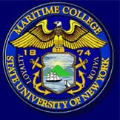



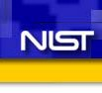


Academic Institutions
SCC, NYIT, Hofstra, SUNY-Westbury, SUNY-MMA

Laboratories

Energy research will be driven by an alliance of universities, laboratories, and
companies.

Improving the present: continuing education programs with SUNY Maritime

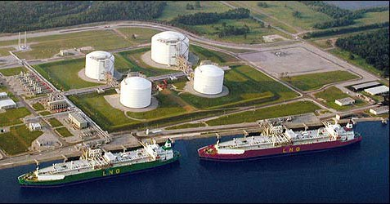
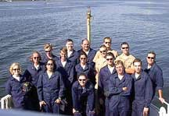
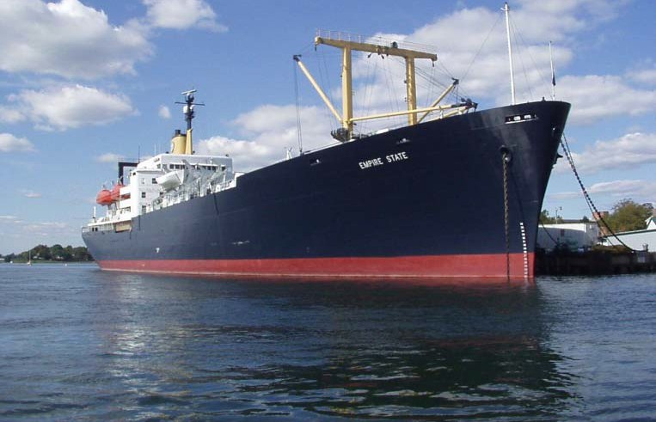
LNG terminal and depot in Louisiana

SUNY Maritime trains 98% of the ship captains that deliver LNG’s into East Coast terminals.

Cadets at SUNY Maritime in basic training. The Empire State training ship is above.

Ensuring the future: Energy Education

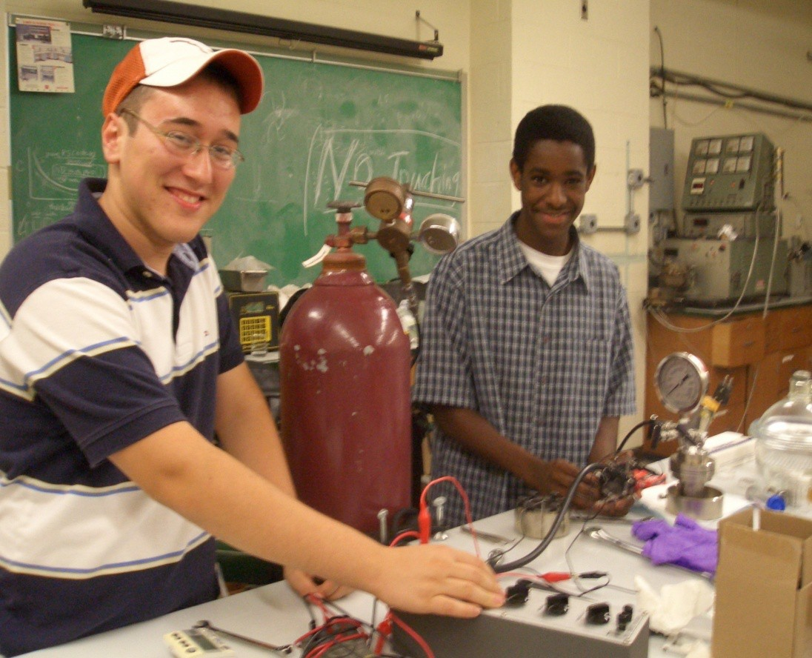
Platinum Nanoparticles: From Hydrogen Storage to Cancer Treatment
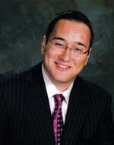
66th Annual STS (2006-2007)
Finalists
Daniel Scott Katz

Ergerie Eugenie, Uniondale High School, Uniondale, New York
Daniel Katz, HAFTR High School, Cedarhurst New York experiment with fuel cell design during a summer high school research program at Stony

Brook University.

AERTC

Why

Application

Outreach

Environmental Responsibility
Sustained Economic Development
Organization of the Energy Center Overview

Who
Stony Brook University
Academic institutions
National laboratories
Industries

What

Research

Leveraging existing capabilities and partnerships, the energy center will promote clean and economical energy through research, application, and outreach efforts.

AERTC-Proposal-DM-200608 Page 7

Organizational Overview
Associate Director Economic Development and Outreach, Education
Associate Director of Research and Engineering











Project Project
Leaders Leaders (Renew. (Hydrogen Energy) Energy)
Project Leaders (Energy Conserv.)
Accredited Educational Programs
University Industry Relations
Project Team
Project Team
K-12 Community Educational Relations
Outreach

Advisory Board Director
Admin. Assistant
Secretary

Project Leaders (Fuel Cells)
Project Leaders (Convent. Fuels)
Project Team
Project Team
Project Team

Support Staff

A director, with the counsel of the advisory board, will oversee the center’s initiatives.
Associate directors, one for outreach, education, and economic development and another for research, technology and engineering, will interface with the five focus groups

AERTC-Proposal-DM-200608 Page 8

Establishment of Advisory Committees
Merged Panel
•Final report
- Natural Overlaps

Advise on Buildings
and Facilities

Basic Research
Engineering Initiatives
Industrial Relations
Accredited Educational Programs
Community Outreach

Fundamental Research : Summary
  - Existing strengths:
Members:
- *Doon Gibbs (BNL)
- *Fu Pen Chiang (USB)
- Clare Grey(USB)
- Emilio Mendez(USB/BNl)
- Kosta Likharev (USB)
- Ben Chu (USB)
- Peter Kahn(USB)
- Grigory Belenki (USB)
- Harry Gafney (QC-CUNY)
Nanotechnology
  - Define distinct focus areas for fundamental research within AERTC.
Biofuels, photovoltaics, portable energy,optimization conventional fuels,catalysis, cogeneration, process modeling and simulation.
  - Identify existing major
instrumentation: BNL
Nanocenter (CNF), Supercomputer
  - Suggest new facilities: Nanofabrication facility and technology testing center.

Engineering
Initiatives Summary

  - Focus areas for engineering
Members:
•
•
•
•
*Ralph James (BNL)
*Serge Luryi
Jon Longtin
(USB)
(USB)
Hazem Tawfik (Farmingdale)
- Steve Eber (Keyspan)
- Cindy Lee (MSRC)
- Kalle Levon (Poly)
- Fritz Henn (BNL)
research: Employ

Nanotechnologies:
Bio-fuels and Bio-Inspired Energy generation systems, hydrogen storage, portable energy, CO2 sequestration, optimization of fossil and coal fuels, catalysis, modeling
and remote sensing.

  - Identify major new facilities to be constructed in the new
AERTC building : New
Technology Testing Facility,
Biofuel Reactor Enclosure,
Organic Synthesis Laboratory,
Nanofab for electronics components and sensors.

Industrial Relations: Summary
Address two major challenges:
Members:
- *Satya Sharma (USB)
- *Mike Furey (BNL)
- Clive Clayton (USB)
- Bruce Germano (LIPA)
- Peter Shkolnikov (USB)
- Jack Harran (Keyspan)
- David Winchester (HIA)

Match technology developed in the laboratory with needs/problems of industry.
- Need to develop a plan which will make BNL user facilities i.e. the Center for Functional Nanomaterials, available to industry.
- Build prototype testing and development facility in “real world applications”.
- Consider expansion to house incubator facility.

Develop Uniform IP protocols for all members,
- Very difficult task since the IP policies vary greatly between private, state, and federal tax levy institutions.
- Issues must be resolved immediately, before large research efforts are initiated and funding is raised from these different sources.
- Must seek the assistance of qualified legal help.

Accredited Educational Programs
  - Establish accredited degree programs in energy at the graduate and undergraduate level.
Members:
- *Marjane Issapour (Farmingdale)
- *Gary Halada (USB)
- Serdar Elgun (Farmingdale)
- Anthony Palmietti (Maritime)
- Sam Yahalom (Maritime)
- John Kincaid (USB)
  - Develop teacher training, workforce development, and continuing education programs in energy.
  - Design distance learning curriculum.

Community Outreach: Summary
Members:

- *Pat Malone (USB)
- *Jack Kramer (Keyspan)
- *Melanie Krieger (POB School)
- Sam Yahalom (Maritime)
- Dave Ferguson (USB)
- Miriam Dietsch (Farmingdale)
- Yelleshpur Dathatri (Farmingdale)
- Ken White (BNL)
- David Manning (Keyspan)
Challenge: Identify the Audience and Plan to Meet their Needs and interests
Future Generations: Sustain
- Develop enrichment programs for introducing energy into the K-12 curriculum.
- “Intel” like science competitions in energy.
- Teacher research and training courses.
General Public:
- Public forums :museums, libraries, senior centers, NGO.
- Web resources.
- Writing and disseminating literature.
Politicians:
- Provide advice on “hot button” topics.
- Assist in drafting policty
- Sponsor workshops.

Recommendations of the advisory committee:
- The building should be open, airy, and have wide public access areas which encourage interdisciplinary interactions between scientists.

- The lobby should accommodate a public information areas, possible a small energy museum and showcase area.

- Research space should reflect the types of laboratory installations that will meet the needs of the research focus groups of the center.

- Organic synthesis
- Bio-fuels greenhouse and Type 2 Micro-organism handling facility
- Nanofabrication
- Modular Systems Indoor/outdoor Large Testing Bay
- Environment/ Nanotechnology cross cutting themes

- Since new research directions are emerging, the space must be versatile in order to accommodate these changes.

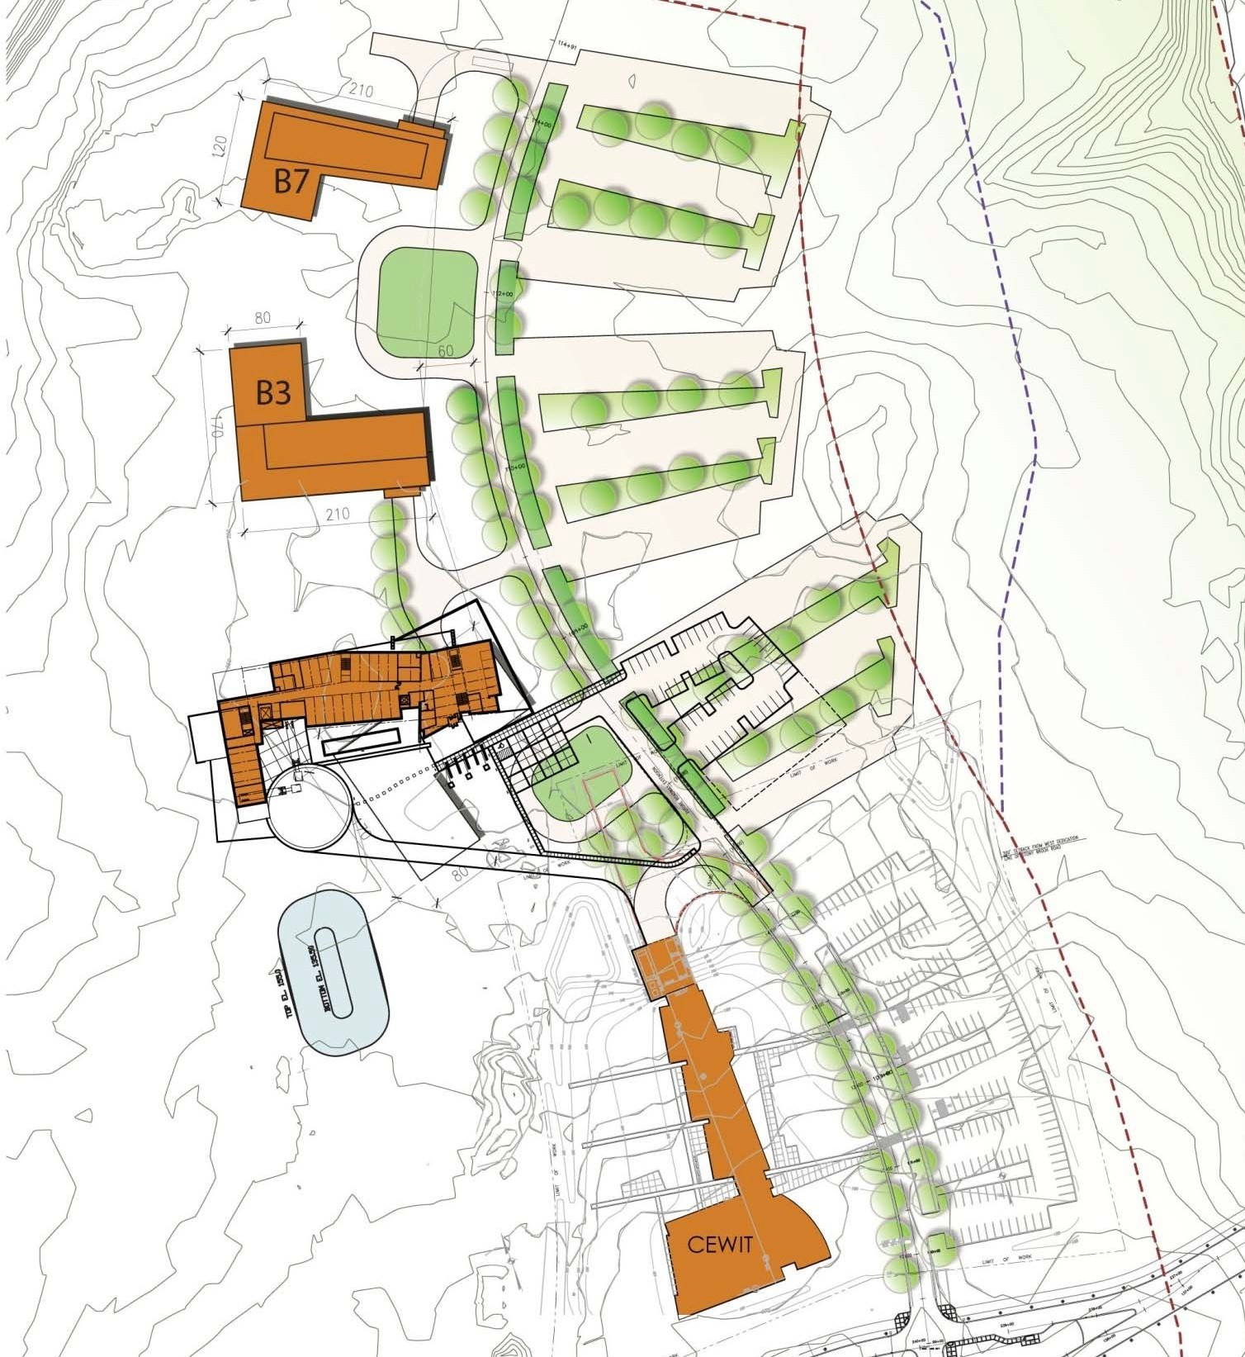

  - Technology Based Research & Development Site

  - Promotion of Interaction Amongst like Minded Science

  - Foster collaboration via shared facilities and amenities

  - AERTC; 50 permanent,
and 50 visiting researchers & staff

AERTC

Mission:

- Encourage Collaboration and Interaction with Private Development
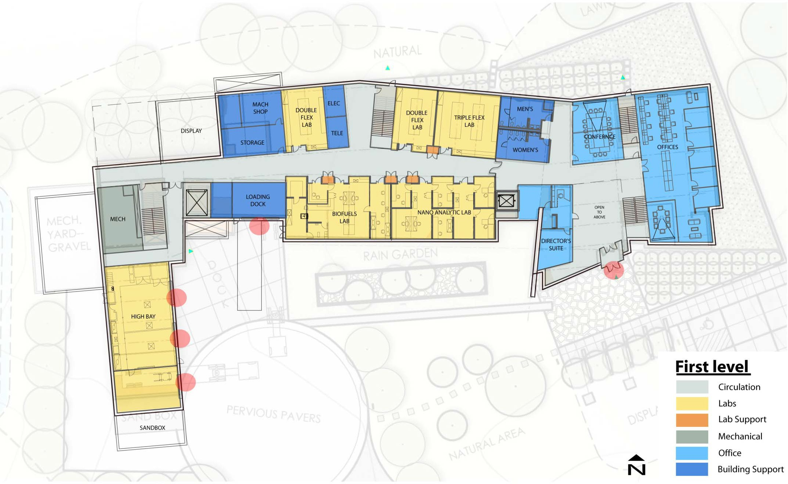

- Separate Labs from Offices

Flexible Labs for Outside Users

Combustion
Bio-handling Lab
Micro-fab Lab

High Bay Area

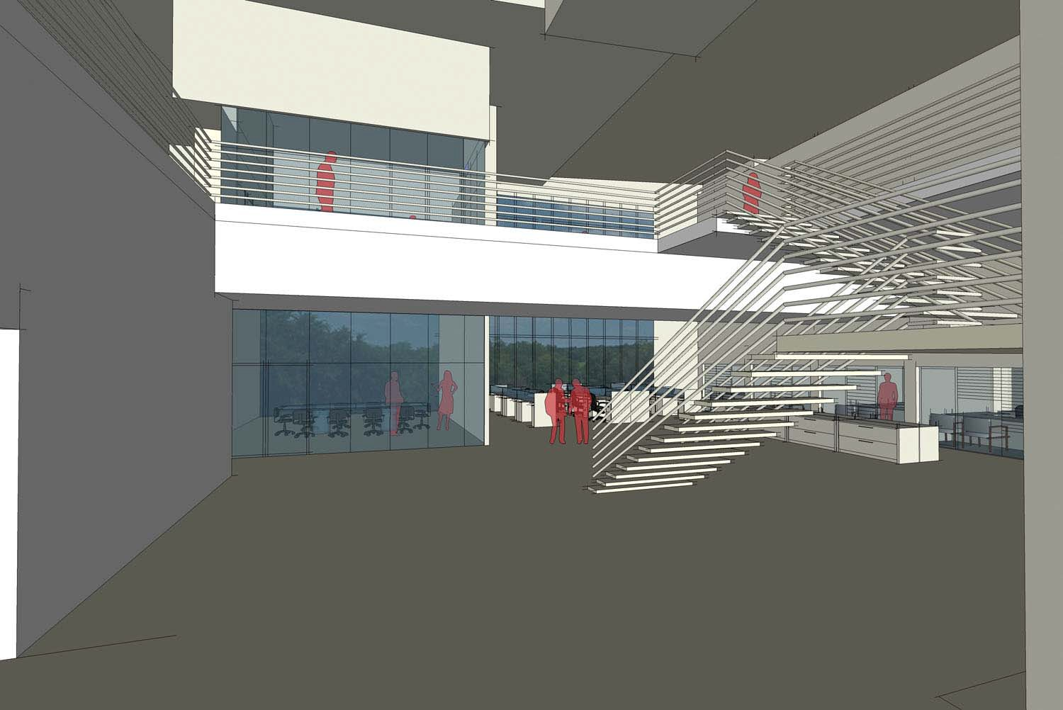
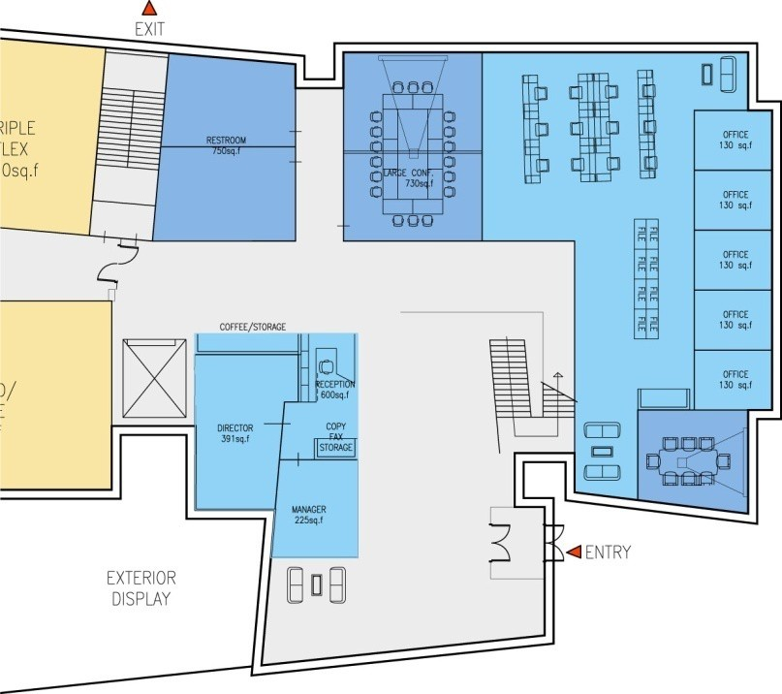
First Floor – Lobby/Entry

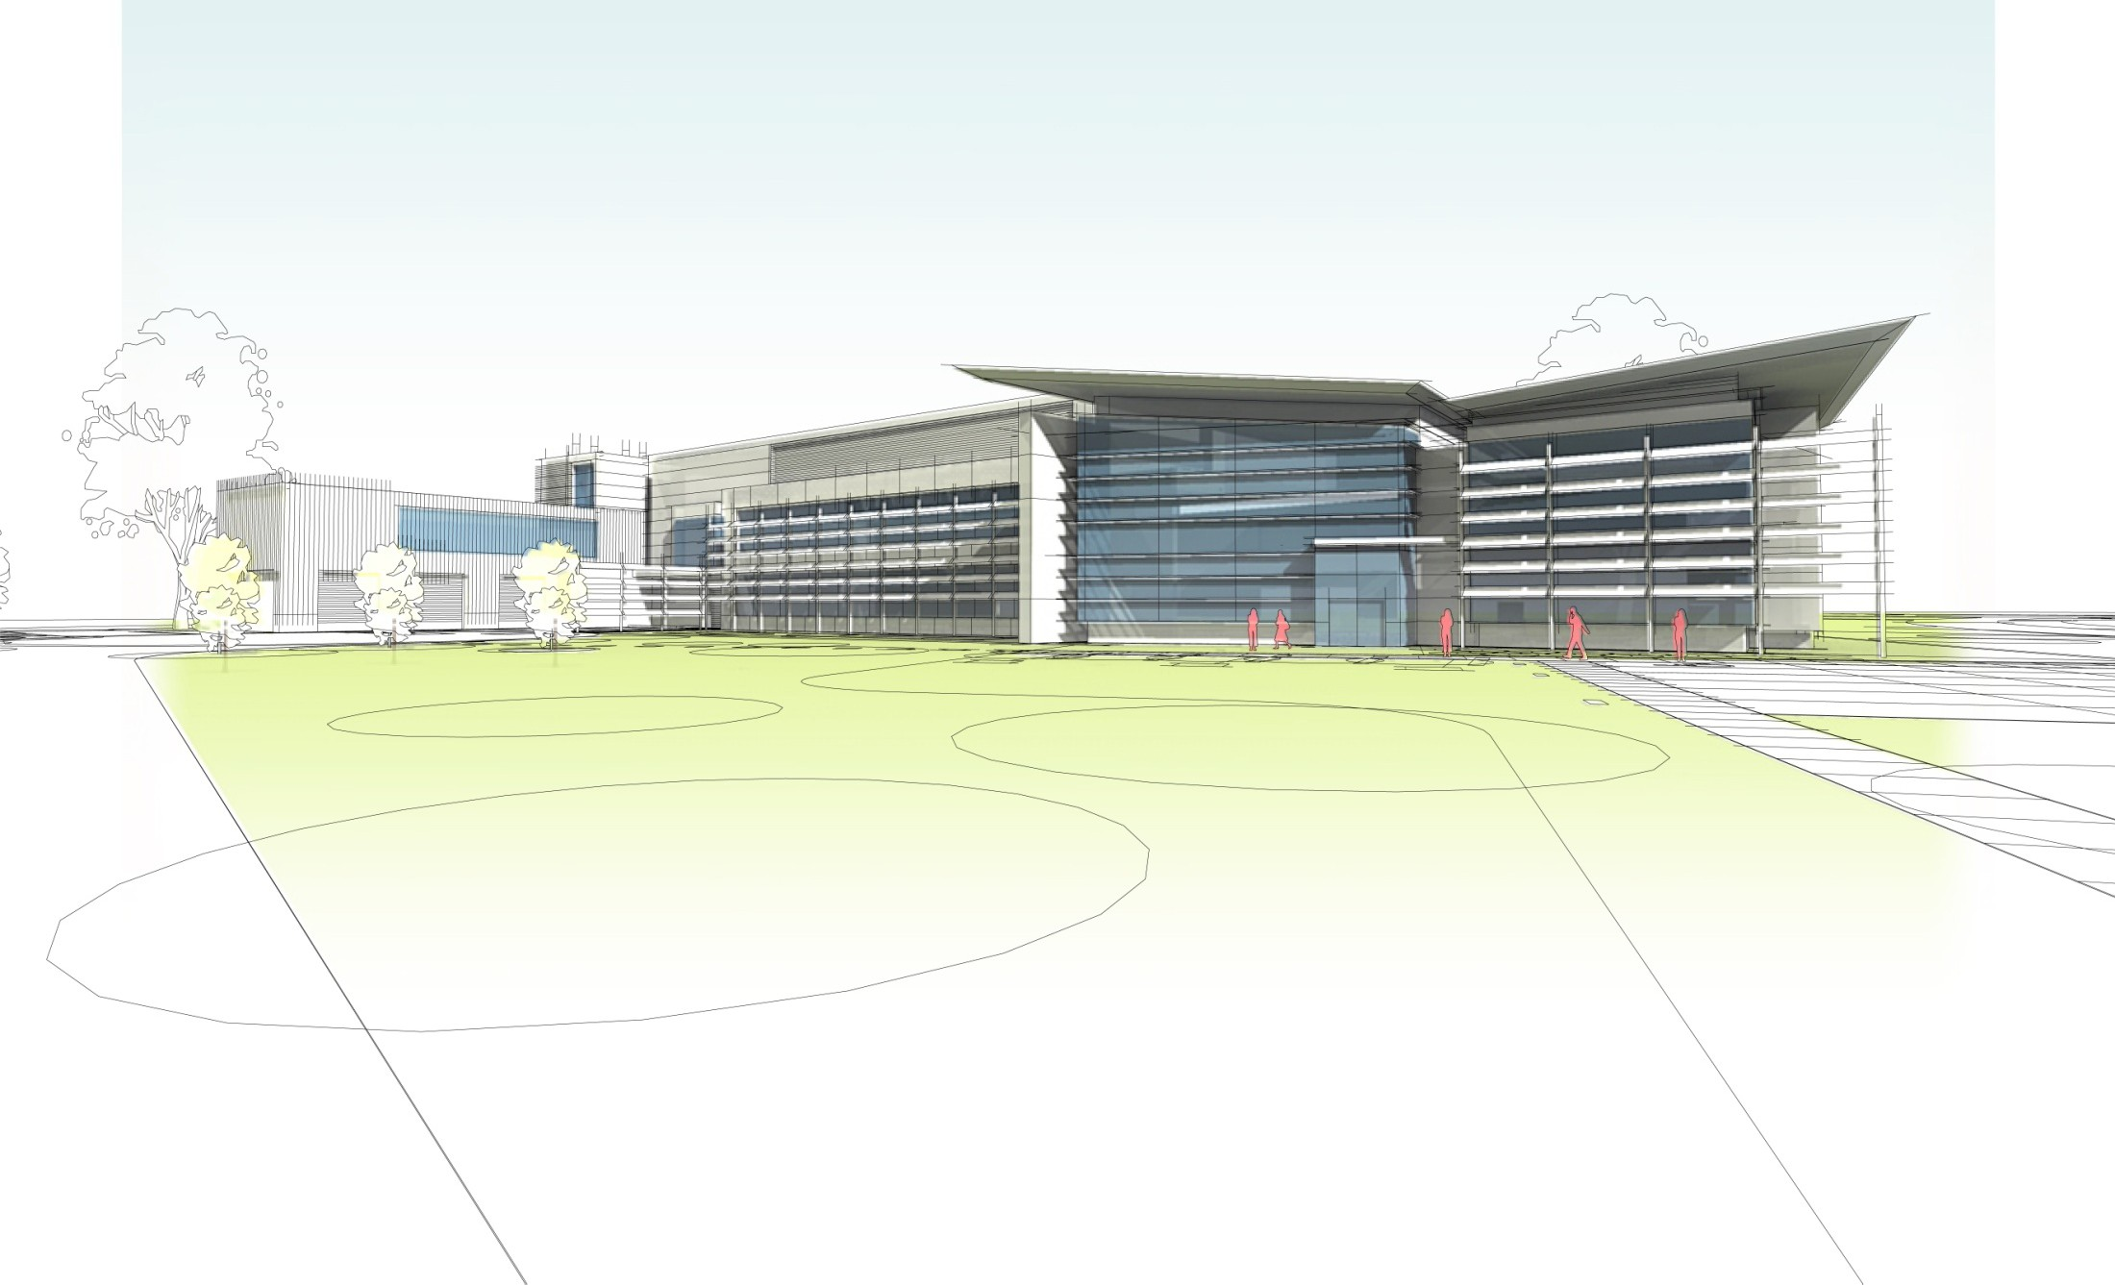

Front lawn and Lobby: Museum and exhibit areas.

Platinum Standard Building
  - Limited parking spaces
  - Solar power co-generation
  - Waste water storage
  - Exposure and vegetation to conserve energy

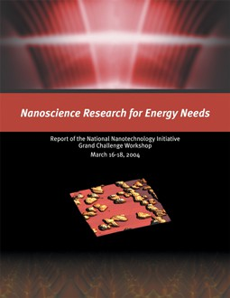
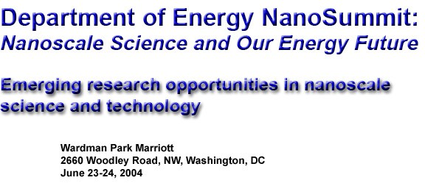
Identification of nine research targets in energy-related science and technology in which nanoscience is expected to have the greatest impact:
    - hydrogen production
    - Highly selective catalysts energy efficient manufacturing
    - Efficient and Inexpensive harvesting of solar energy
    - Solid-state lighting for lower power consumption
    - Super-strong, non-flamable light-weight materials
    - Reversible hydrogen storage materials operating at ambient temperatures
    - Power transmission lines capable of 1 gigawatt transmission
      - Low-cost fuel cells, batteries, thermoelectrics, and ultra-capacitors.
•Energy Harvesting based on the efficient and
selective mechanisms of biology .

Selected Current Energy Research Projects

- Micro/Nano Mechanics Studies of Sandwich Foam Composites
- Hydrogen Storage and Quantum Level Calculations
- Lighting Technologies
- In-Situ Monitoring of Gases and Pollutants
- Electric Load Forecasting
- Methane hydrate formation
- Photovoltaic Cells for Electric Power Generation
- Combustion Process
- Laser Fusion and Turbulent Mixing
- Nanotechnology and Chemical Sensing
- Alkaline Batteries for Primary Batteries
- Lithium Batteries for High-Power Applications
- Solid Oxide Fuel Cells: Studies of Ionic Conductivity
- Thermal Spray Center for Fuel Cells and Engines
- Environmental Nanotechnologies for Clean Energy Applications
- Water-Air Quality Sensing Project (WASP)
- Fuel Cells
- Fuel Injection into the Plasma Reactor (ITER)
- Thermosetting Polymers as Lighter and Tougher Materials
- Internal Combustion Engine
- Thin-Film Photovoltaic Reliability and Lifetime Assessment
- Extremely Low-Power Hybrid Silicon/Nanoelectronic Circuits
- Oxide Nanomaterials for Energy Applications
- Measurement of Carrier Recombination Parameters in III-V Compounds for Photovoltaic Cell Design Optimization
- Internal Combustion Engine
- Bio-inspired Smart Green Building
- Nanofibrous Membranes for Energy Applications
- Harvesting Wave and Tidal Energy
- Surface Metrology for PV Wafers
- Wafering and Manufacturing of Photovoltaic Solar and Thermal PV Cells

Methane Hydrate: A clean alternative fuel
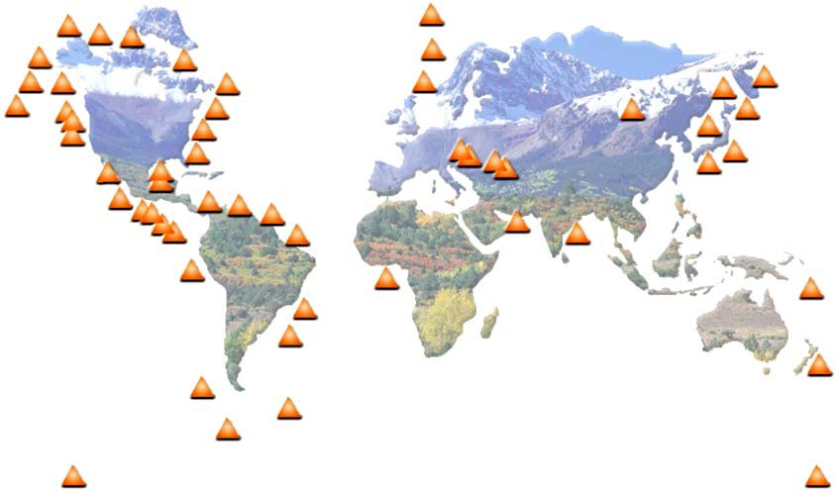
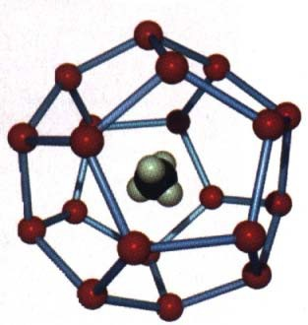
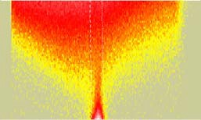
T. Koga, M. Rafailovich (USB), S. Satija (NIST), J. Jerome (SCC), D. Mahajan (BNL) CH4

Hydrate formed: 800 psi, 6oC
Higher q
Water cage

Methane hydrate crystal

Advantages:

Location of Hydrate deposits around the globe.

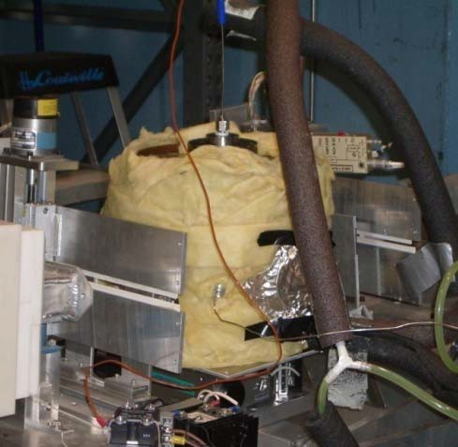
- 20,000 trillion cubic meters of methane stored in the underwater deposits.
High pressure cell
Neutrons
NG7, NIST
- Quantity is larger than all of the current fuel sources !!
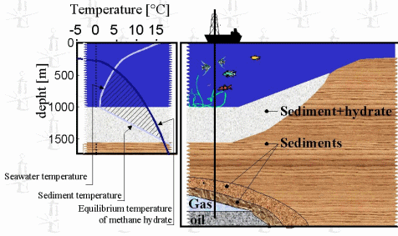
- Hydrates uniformly distributed geographically, minimize political tensions.
The challenge:
  - Stable at low Temp (4 C) and high P (~800 PSI)
  - Must be mined from under the ocean floor .
  - Very hard crystals. Known to foul mining equipment.
The solution:
  - Neutron scattering: High precision phase diagrams
  - Molecular surfactants control nucleation
  - Simulate underwater conditions, provide total control.
Source:GasHydye Center

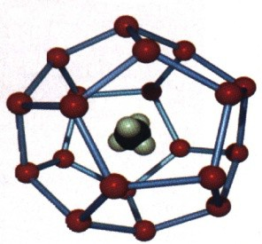
Methane Hydrates- Sediments Characterization
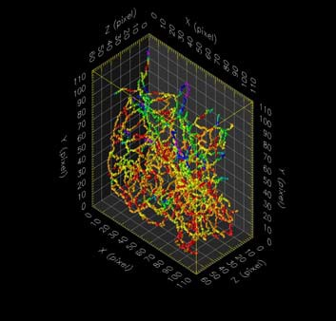
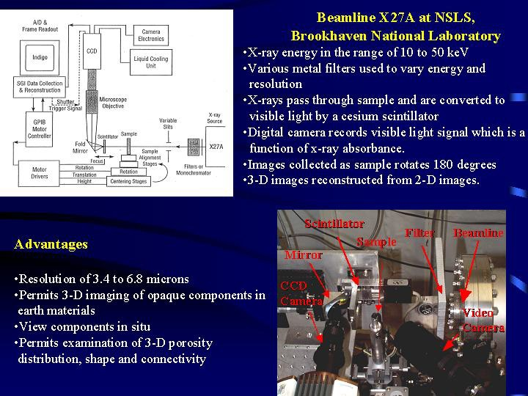
Pure Methane hydrate (without host sediment)
sI

3-D CMT Data at NSLS

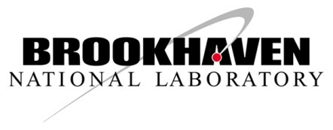
Brookhaven Science Associates
U S Department of Energy


Polymers for Energy Polymers are an enabling technology implicated in diverse applications.
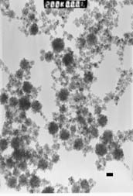
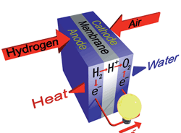
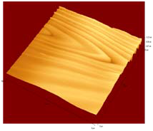
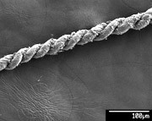
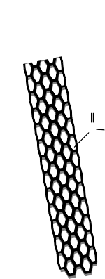
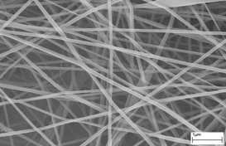
- Proton Exchange Membrane Fuel Cell:
Current is produced when charged Nafion polymeric membranes allow diffusion of H+ ions to the cathode. MRSEC researchers developed new thiol functionalized Pt or Pd nanoparticles films which increased power production by more than 30%.

MIT

O CH₃
n
- Carbon-polymer nanocomposites: MRSEC researchers have demonstrated that carbon nanotubes can be electrospun into nanofibers which are ultra strong and lightweight , conducting and fireproof. Millions can be twisted together to produce

C NHCH2 C
Hlow loss cables for high current applications.

C O O CH₃

- Supercritical carbon dioxide processing: MRSEC research has found new regime in supercritical CO2 phase diagram where it becomes a universal solvent. Potential for green, low energy processing and cleansing of LNG transmission networks.

Ba rri er
W
ate r

Mem brane

Monol ayer

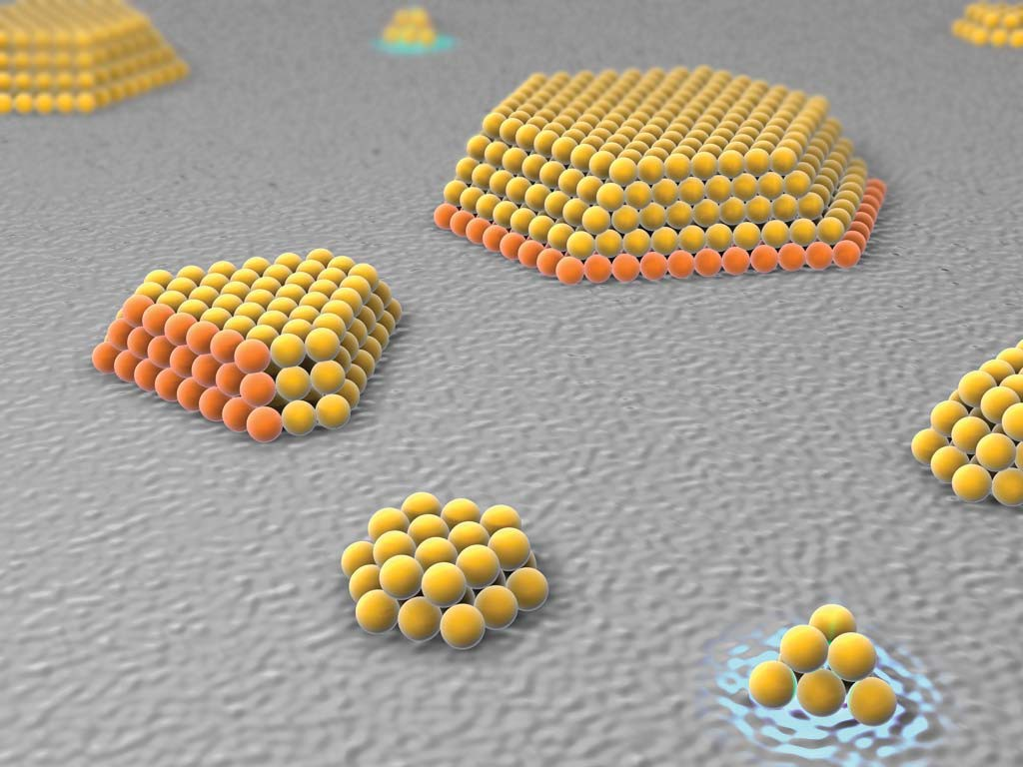
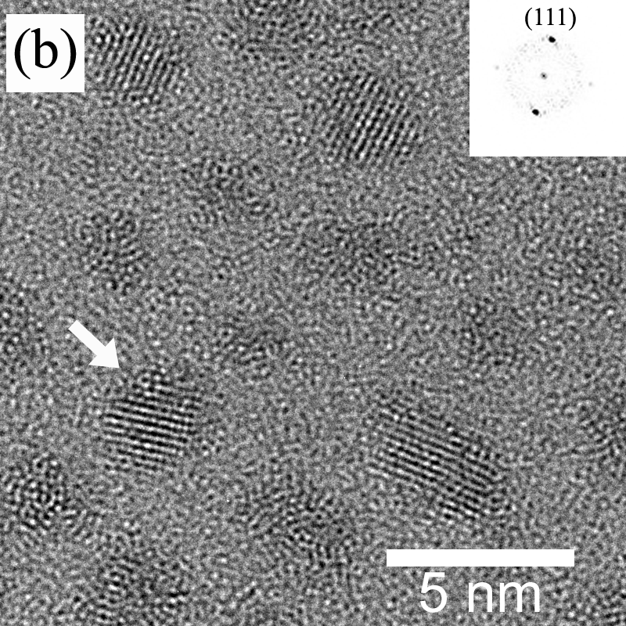
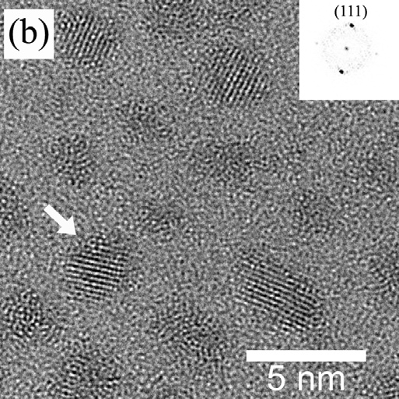
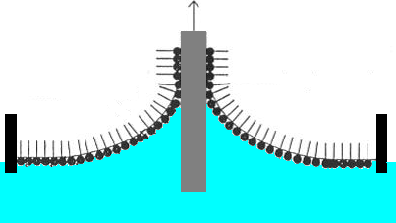
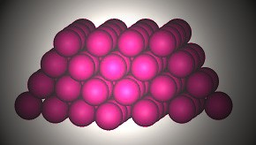
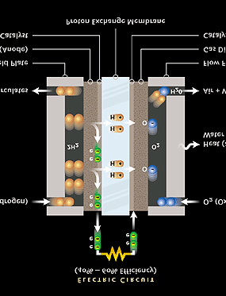
180
160
140
120
100
P (mW)
80
60
40
20
0

Au-thiol 1:1
Au-thiol 2:1
Au-thiol 3:1 Control
0.0 0.1 0.2 0.3 0.4 0.5
I (A)
180
160
140
120
100
P (mW)
80
60
40
20
0

100%

Control

258%

Pd-thiol 2:1

541%

Au-thiol 1:1


Energy Conservation & High-Efficiency Ultra-Filtration
Chu Hsiao-Yoon

Ex: Wastewater Generation in Navy Ship
300-man ship: 16,000 gal/day ~ 66 ton/day
- Black water (sewage) : 6,000 GPD
- Gray water (kitchen, showers, laundry) : 4,000 GPD
1-lb water purification – 56 BTU (British Thermal Unit)
- Bilge water (bilge) : 6,000 GPD
Energy saved by a factor of ∼20
EX: single stage RO plant with Diesel Gen-set

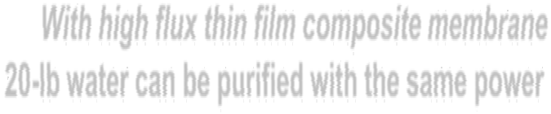
With high flux thin film composite membrane
20-lb water can be purified with the same power

80% reduction in power for membrane processing method vs. other methods
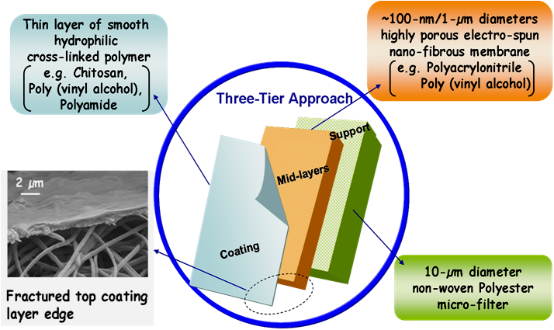
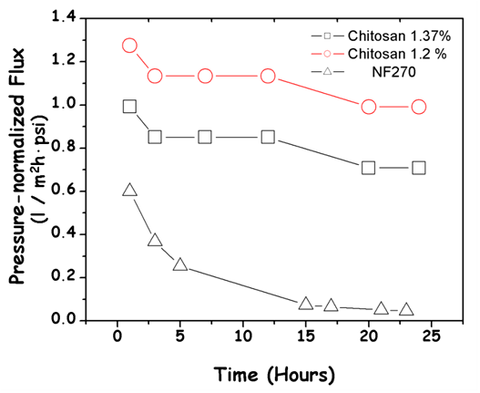

New approach for high flux membrane
∼20 times higher flux than conventional membranes

Plastics Recycling

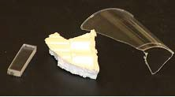
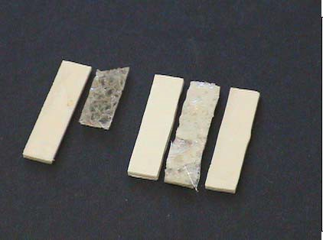

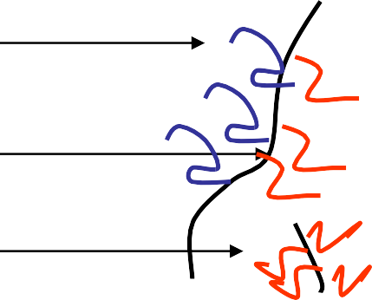
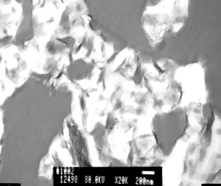
 Plastic recycle industry

Melt Mixed

Clay

PS/PM PETE/

C type

PS

Clay
PS/PMMA/C20A PS/PMMA
PS/PMMA/PET/C20A/C6A PS/PMMA/PET

platelet
α = 5Eh
1/4

PMM A

A type
(
4(γ
−γ ,))

Conventional Energy Project: Smart Grid

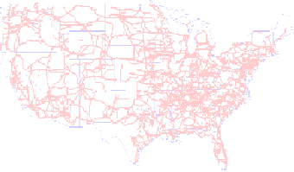


Critical first step in power conservation is to maximize the efficiency of the power distribution system
- SBU, BNL , Blue Gene consortium and SUNY Maritime are applying their high level computational techniques to evaluate power distribution networks, and to design “smart grids” capable of making decisions to remediate local failures in nodes and to optimize distribution when cogeneration from multiple sources is activated.

Super-tough materials using biomimetic principles
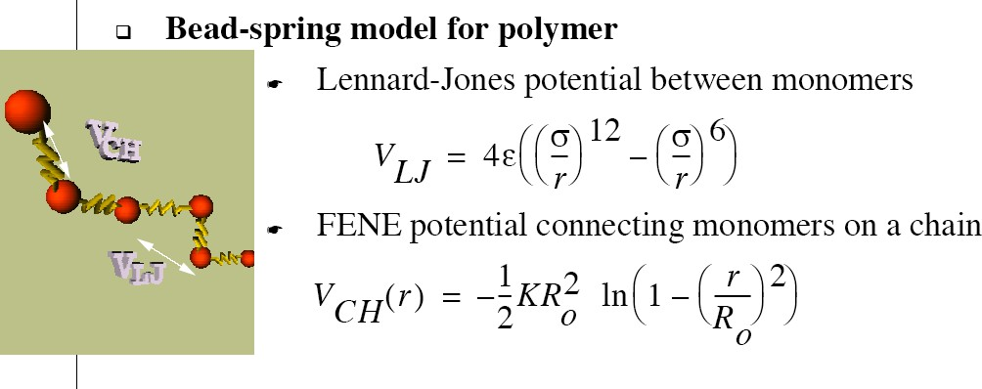
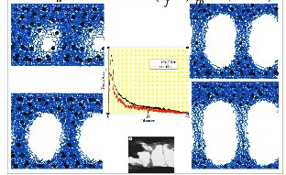
(1) (2)

(3)
MD simulations of failure in polymer nano-composites

Polymer nano-composites show similar behavior to naturally occuring materials

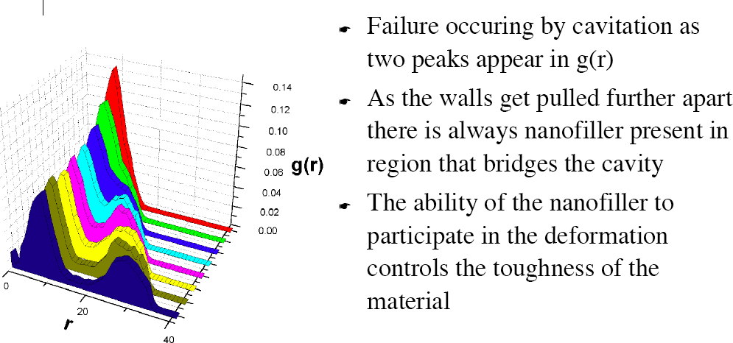
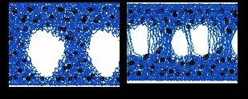
(4)

Super-toughening occurs only above Tg
-- effect of fillers related to filler mobility

Improving processability and wettability of materials
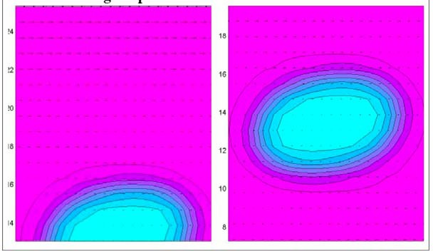
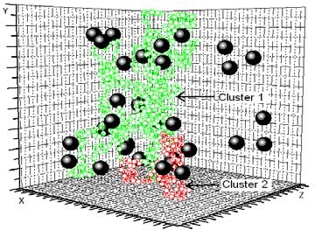
(1) (2)

QuickTime™ and a TIFF (LZW) decompressor
are needed to see this picture.

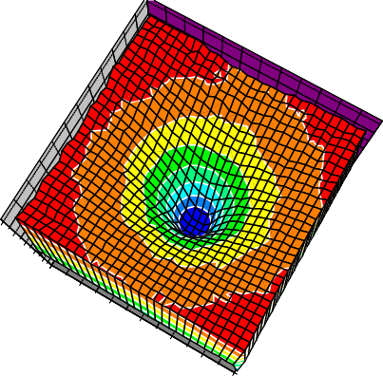
(3)
Reduce energy cost of processing --polymer blends under shear

(4)

Rheology of polymer nanocomposites --percolation & flow

2500
2000
1500
1000
500 00
Z Axis
30

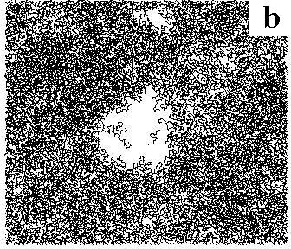
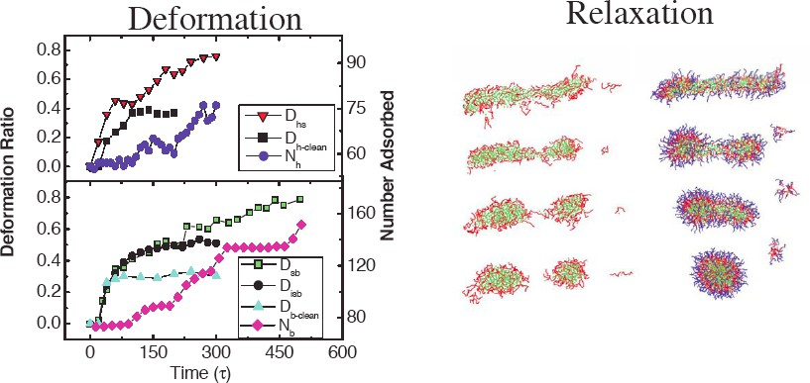
25

20

5 15
Y Axis
10 10
15
20 5
X Axis
25
30 0

Stability of thin films -- lubrication applications
Emulsions and surfactants in shear flows --improving mixing

How do they work?
Source: http://www.ceficefra.org/frames/f_how_fr_work.html?=how_fr_work.html
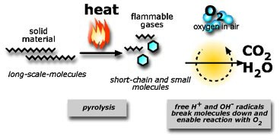
- Polymers are decomposed by pyrolosis and emit hot flamable gases.
- These gases contain H and OH radicals, which react with oxygen in the air to “burn” to CO₂, emitting heat.

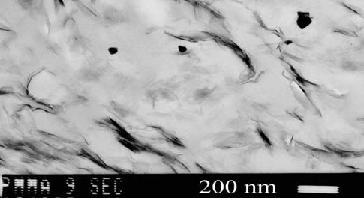
Flame retardant and Self Extinguishing Materials
Clay platelets
Clay
9sec

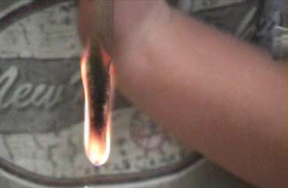

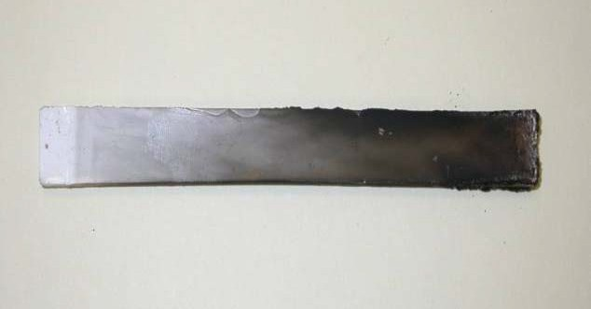

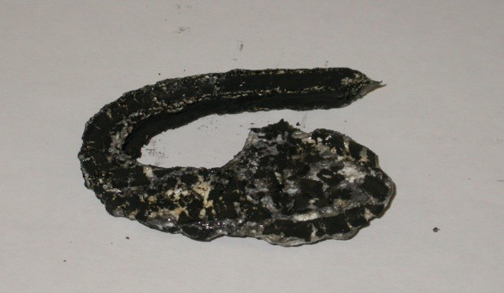
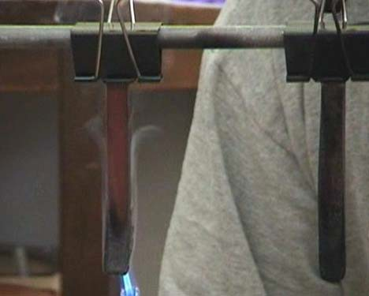
Engineered Nanocomposite Polymers that are tough, conduct , and self-extinguish!
(UL94-V5)

Photovoltaics: TiO₂ particles
The Enviroment: Social Responsibility • ^{Large} ^{particles}
are Talc.
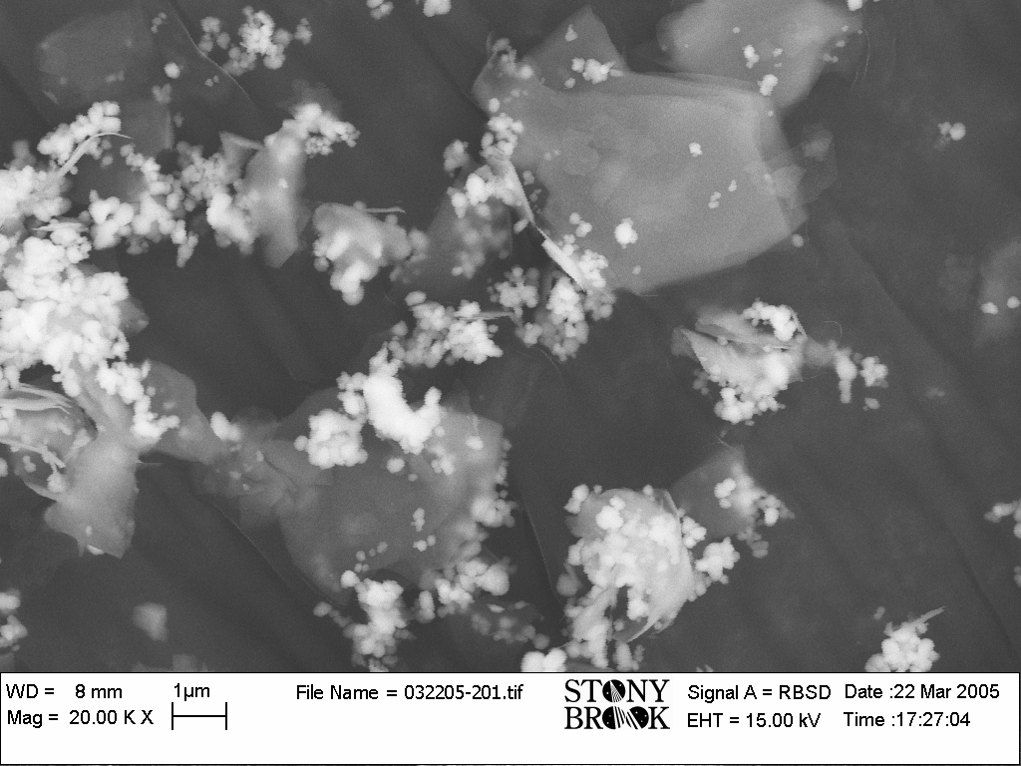
  - Smaller ones (~10nm) are TiO2 particles.
  - Titanium dioxide is used in most sunscreens to help prevent UV radiation burns.
  - Zinc is also used in sunscreens as a UV blocking agent.

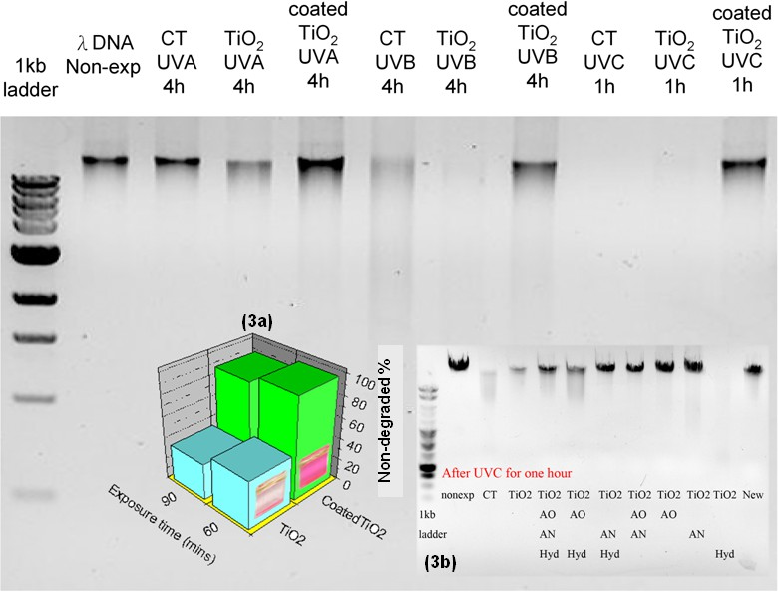
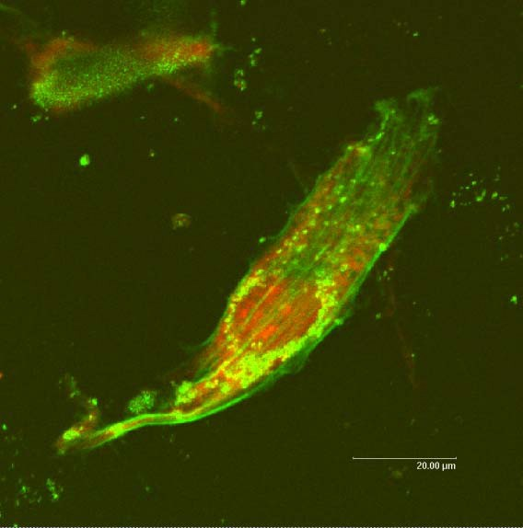
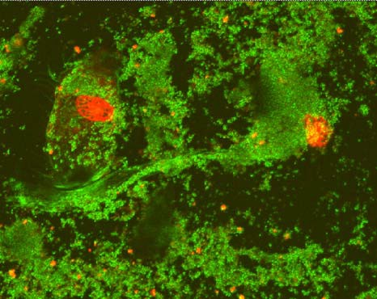
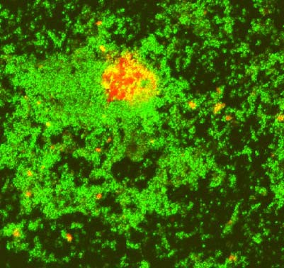

- TiO₂(with talc): 0.1 0.3 0.5
- microgram/ml


Osteoblasts cultured on EVA with clay and Fe2O3
B

EVA+Clay/NO magnets EVA+Clay/magnets EVA+Clay+Fe₂O₃/magnets
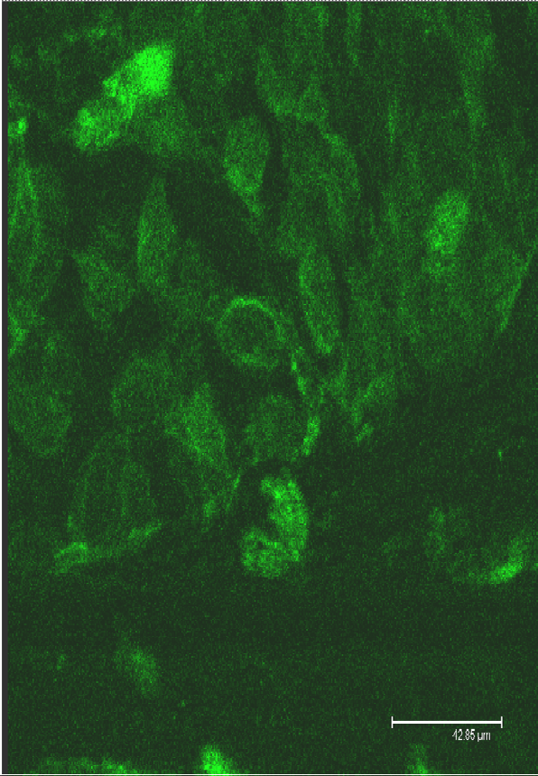
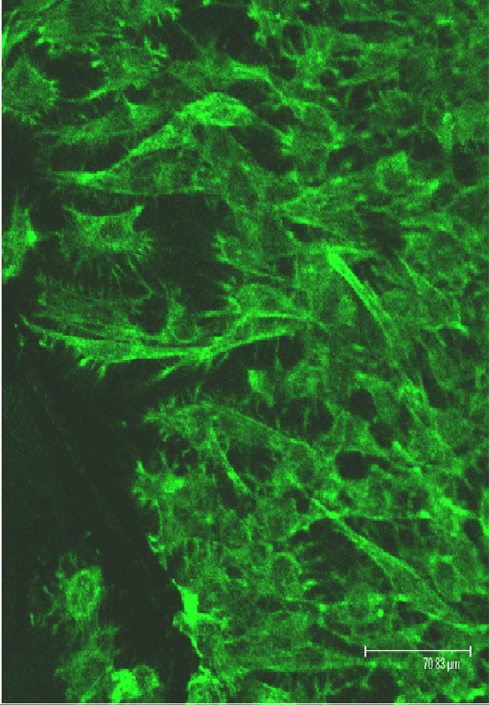
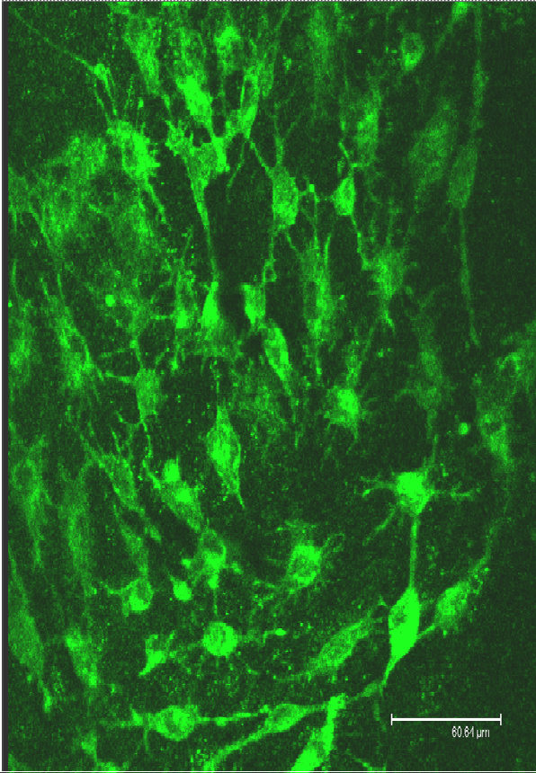

Tissue formation and cell orientation in external field.

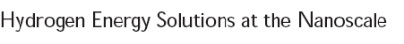

A partnership between
Basic Energy Sciences and the Center for Functional Materials
Challenge: Meet Department of Energy Mandate to develop hydrogen batteries and fuel cells for powering cars, homes, and business by 2015.
Conditions: Produce materials that are inexpensive, safe to handle and dispose, and can be mass produced, which have high reactivity and capacity to store hydrogen.

  - Nanostructured catalysts: Nanoparticle Ru scaffold for Pt atomic Clusters. Pt atoms have the high catalytic efficiency, while Ru keeps the manufacturing costs low. Pt catalysts remove CO emissions for clean and efficient burning of conventional fuels.
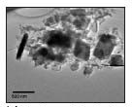
  - LiAlH₄ Lithium aluminum hydrides reversibly decompose to form nano-platelets, 100nm thick. New type of electrodes for Li batteries with extremely high efficiency for hydrogen storage and power generation.

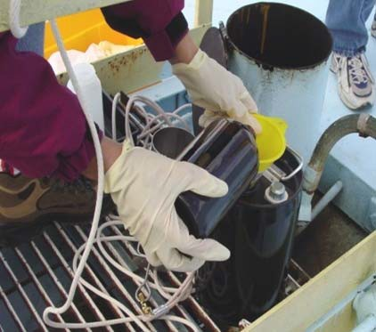
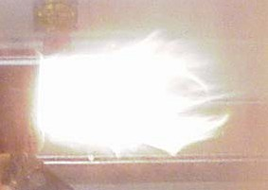
Biofuels Combustion at BNL Focus on Stationary Applications
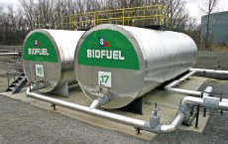
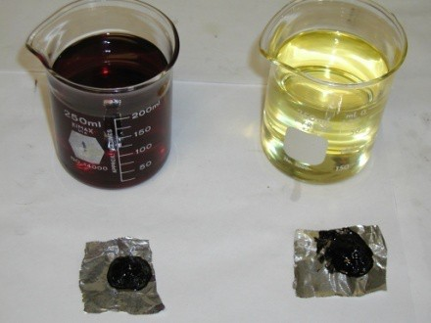
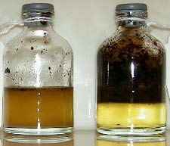
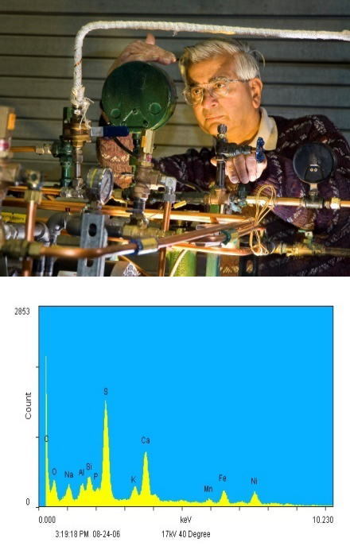
Combustion studies – boiler and turbines Field Trials
Support for Codes and Standards Properties
Storage and Thermal Stability Burner Development
Blend Sensor
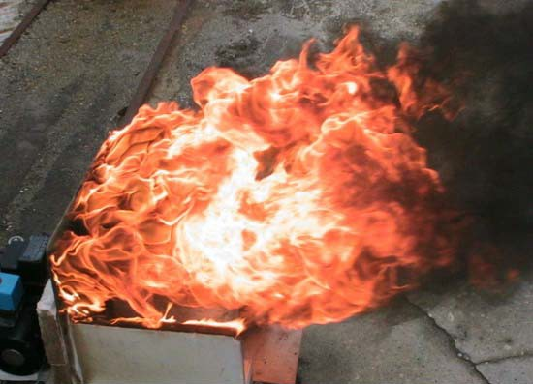
MicroCHP Engine Development Ultra-high efficiency biofuel boiler

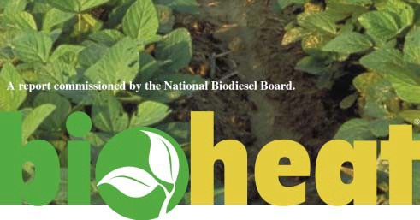

RFP
- $50K/yr to fund joint collaborative research
- Areas related to energy
- Seed grant for future funding

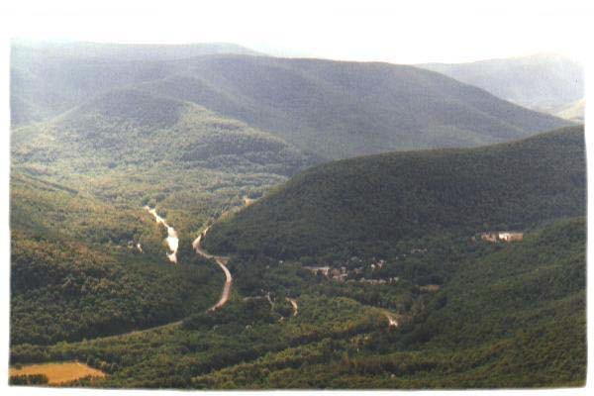


Conclusions
  - Please join us in the ribbon cutting ceremony tomorrow for a new center for Advanced Energy Research and Technology. The center is partnership between academic institutions, national laboratories, and industry.

  - The mission of the center is to combine nanotechnology and engineering in order to (a) pursue cutting edge research on new and traditional energy sources, (b) establish demonstration sites to test and evaluate new technologies, and (c) increase public awareness of energy issues and policy through outreach and education programs

