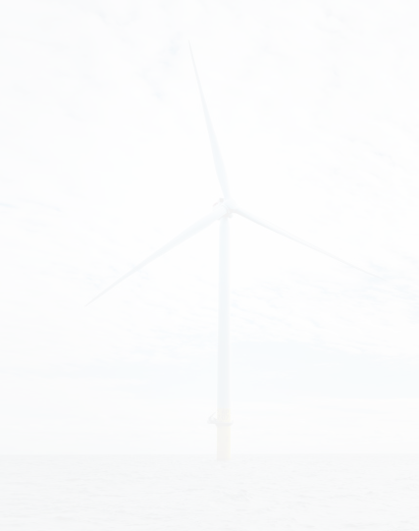
South Fork Wind is a 12-turbine, 132 megawatt (MW) offshore wind farm powering 70,000 homes across Long Island, New York. Located 35 miles east of Montauk Point, the wind farm delivers power to the local substation in the Town of East Hampton through a series of transmission cable systems buried in the sea floor.
FAST FACTS
Size
132 megawatts, 12 turbines

Homes Powered
70,000

Completion
March 2024

Developer
Ørsted

Contract Of-Taker
Long Island Power Authority

Figure 1: South Fork Wind Interconnection Map

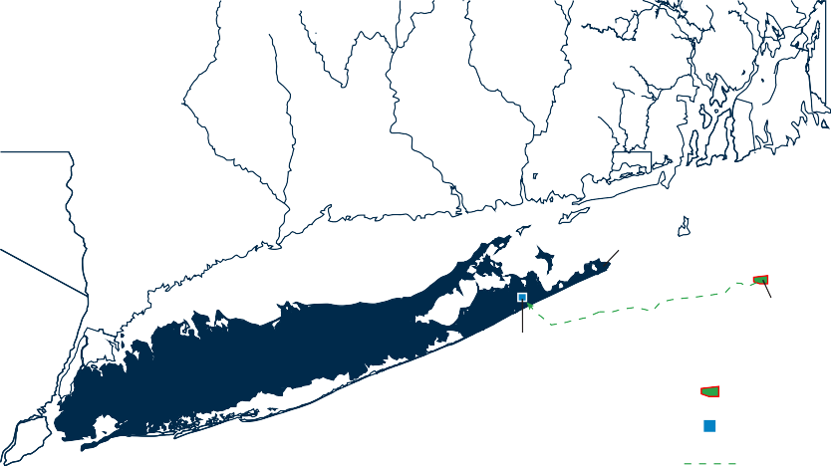
MA

RI
CT

Rhode Island Sound

NY LO N G i S L A N D S O U N D

Block Island Sound

Montauk

South Fork Wind Farm

NJ East Hampton Substation

AT L A N T iC O C E A N
South Fork Wind Lease Site

Point of Interconnection to LIPA Grid via East Hampton Substation
Undersea Transmission Route

South Fork Wind was first approved by the Long Island Power Authority in 2017 to meet the growing electricity demands of Long Island’s ‘South Fork’ – a peninsula in the southeastern section of Suffolk County on the South Shore of Long Island.

Following a comprehensive design, development, and permitting process, construction took two years to complete once the project’s final approval was granted.

Milestone Timeline

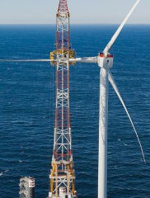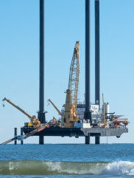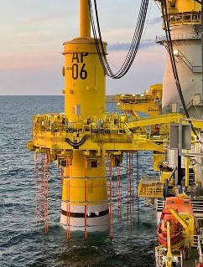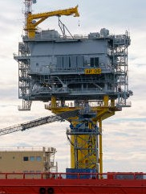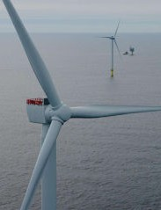

Groundbreaking
Onshore Cable Installation
First Monopile Foundation
Offshore Substation Installation
First Turbine Installation
Full Commissioning

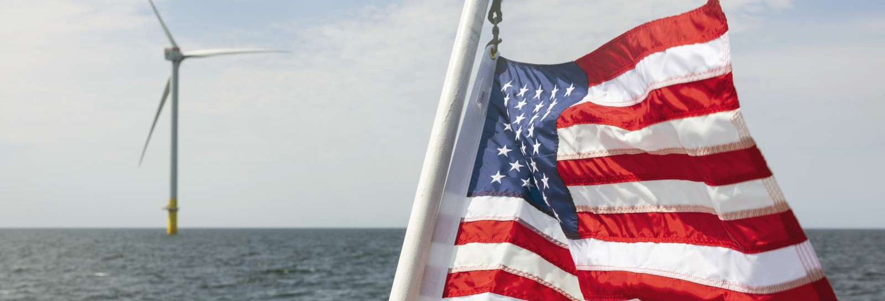
SOUTH FORK WIND FARM
FACT SHEET
Innovation That Works: America’s First Commercial-Scale Offshore Wind Farm
February 2022 May 2023 June 2023 July 2023 November 2023 July 2024

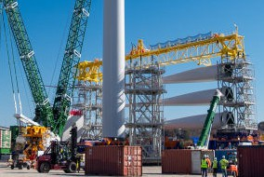
American Manufacturing
The project features the country’s first American-built offshore substation, constructed by Kiewit near Corpus Christi, Texas, and is the first offshore wind farm to use an American-made and -crewed service operations vessel, the ECO Edison, built by Edison Chouest in Houma, Louisiana.

In addition, South Fork Wind’s export cable was made in South Carolina, its foundation components in Rhode Island, and the turbines’ onshore assembly occurred in Connecticut.


American Jobs
South Fork Wind has provided numerous economic benefits to the local economy, including creating nearly 1,000 jobs across New York and four other states, creating new business for local companies, supporting training programs, and more. It’s providing clean, reliable, and affordable electricity and supporting the buildout of America’s offshore wind industry.

Wind Farm Production: Performing as Expected
In its first year of operation, South Fork Wind has proven that offshore wind is a reliable and dependable energy source.
While wind patterns are seasonal and vary by geographical location, offshore wind energy production in New York is highest during the winter months, when winds are the strongest and most consistent. However, offshore wind turbines generate power almost all the time.

Electric Grid Flexibility
Grid flexibility refers to the electricity grid’s ability to adapt in real-time to changing conditions, including fluctuations in demand (how much energy is being consumed) and supply (how much energy is being generated), to maintain stable and reliable power. Even with the build-out of offshore wind, LIPA will remain dependent in the near term on some imports and local dispatchable resources for reliability, including fossil-fueled generation, to balance growing electric demand.

Figure 2: South Fork Wind Production
60,000

50,000

40,000
MWhs

30,000

20,000

10,000

0
Aug-24 Sep-24 Oct-24 Nov-24 Dec-24 Jan-25 Feb-25

Monthly Production (in MWh)

In the next decade, new technologies and clean fuels will be needed to replace the operational flexibility of fossil generation with Dispatchable Emission-Free Resources, such as long-duration battery energy storage, hydrogen, and carbon capture and sequestration.

Frequently Asked Questions

How much do customers pay each month for South Fork Wind?
LIPA has a long-term agreement to purchase the energy produced from South Fork Wind. ~$1.58 per month is the estimated net bill impact for a typical residential customer (i.e., the incremental cost).

How often are wind turbines producing energy?
A modern offshore wind farm, like South Fork Wind, produces electricity nearly all the time, but it generates different outputs depending on the wind speed. South Fork Wind’s technology produces maximum power at wind speeds of around 30 mph.

What is the capacity factor?
The capacity factor is the average power output divided by its maximum power capability over a given period and is typically shown as a percentage.
Over the course of a year, South Fork Wind will generate a percentage of its maximum output. For example, in November 2024, its capacity factor reached 56%, consistent with baseload generators.
For more information, visit SouthForkWind.com.

